
The Republic of India is a country in South Asia which comprises of the majority of the Indian subcontinent. India has a coastline which stretches over seven thousand kilometres, and shares its borders with Pakistan to the west, the People's Republic of China, Nepal, and Bhutan to the northeast, and Bangladesh and Myanmar on the east. On the Indian Ocean, it is adjacent to the island nations of the Maldives on the southwest, Sri Lanka on the south, and Indonesia on the southeast. India also claims a border with Afghanistan to the northwest.
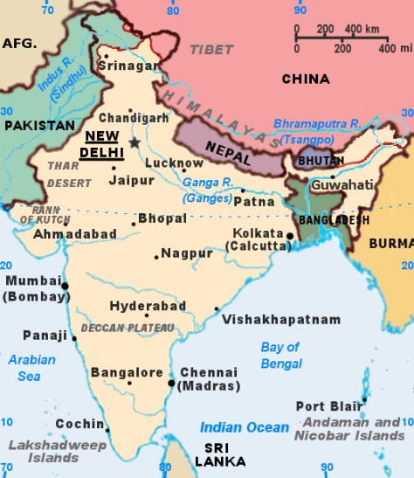
India is the fourth largest economy in the world in terms of purchasing power parity. It is the second most populous country in the world, with a population of over one billion, and is the seventh largest country by geographical area. It is home to some of the most ancient civilizations, and a centre of important historic trade routes. Four major world religions: Hinduism, Buddhism, Jainism and Sikhism have originated from India. Formerly a major part of the British Empire as the British Raj before gaining independence in 1947, during the past twenty years the country has grown significantly, especially in its economic and military spheres, regionally as well as globally.
During the middle of the second millennium, several European countries, including the Portuguese, Dutch, French, and British, who were initially interested in trade with India, took advantage of fractured kingdoms fighting each other to establish colonies in the country. After a failed insurrection in 1857 against the British East India Company, popularly known in India as the First War of Indian Independence and most commonly known in the West as the Indian Mutiny, most of India came under the direct administrative control of the crown of the British Empire.
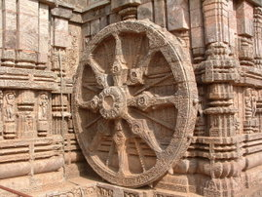
'The Wheel of Konark'. The Sun Temple at Konark, Orissa built in the 13th century, is one of the most famous monuments of stone sculpture in the world.
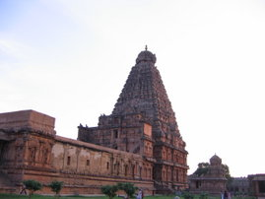
The Brihadisvara Temple or "Big temple" in Tanjavore was built by the chola emperor Raja Raja Chola in the 10th century AD.
In the early part of the 20th century, a prolonged and largely non-violent struggle for independence, the Indian independence movement, followed, to be eventually led by Mahatma Gandhi, regarded officially as the father of modern India. The culmination of this path-breaking struggle was reached on 1947-08-15 when India gained full independence from British rule, later becoming a republic on 1950-01-26.
As a multi-ethnic and multi-religious country, India has had its share of sectarian violence and insurgencies in different parts of the country. Nonetheless, it has held itself together as a secular, liberal democracy barring a brief period from 1975 to 1977 during which the then Prime Minister Indira Gandhi declared a "state of emergency" with the suspension of civil rights. India has unresolved border disputes with China, which escalated into a brief war in 1962, and Pakistan which resulted in wars in 1947, 1965, and 1971, and a border altercation in the northern state of Kashmir in 1999. India was a founding member of the Non-Aligned Movement and the United Nations. In 1974, India conducted an underground nuclear test, making it an unofficial member of the "nuclear club", which was followed up with a series of five more tests in 1998. Significant economic reforms beginning in 1991 have transformed India into one of the fastest growing economies in the world and added to its global clout.
India is divided into twenty-eight states (which are further subdivided into districts), six Union Territories and the National Capital Territory of Delhi. States have their own elected government, whereas Union Territories are governed by an administrator appointed by the union government, though some have elected governments.
India's entire north and northeast states are made up of the Himalayan Range. The rest of northern, central and eastern India consists of the fertile Indo-Gangetic plain. Towards western India, bordering southeast Pakistan, lies the Thar Desert. The southern Indian peninsula is almost entirely composed of the Deccan plateau. The plateau is flanked by two hilly coastal ranges, the Western Ghats and Eastern Ghats.
India is home to several major rivers such as the Ganga (Ganges), the Brahmaputra, the Yamuna, the Godavari, and the Krishna. The rivers are responsible for the fertile plains in northern India which are conducive to farming.
The Indian climate varies from a tropical climate in the south to a more temperate climate in the north. Parts of India which lie in the Himalaya have a tundra climate. India gets most of its rains through the monsoons.
