Halloween
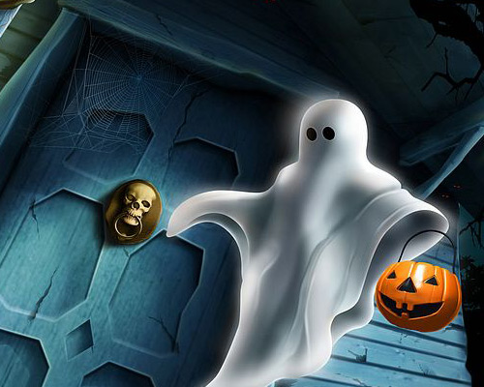

I better close and park resembled a ghost or a bat, I could not see very well because it was fog. Instead, I saw many bats that passed right over my head, I spariat least for the moment, but then I went. But suddenly like I ended up in another place, because when I was nearly like a trap, all bats, all Ghosts, all devils, all zombies and other creatures at the same time scary and strange. All approached increasingly more than me.
Then I was made one fear, so that we know what to do before, so I took her to run as his feet kept mau, but at some point I tripped and I fell down ... after I got up I went on and I met with (pumpkin lantern). He told me his whole story of what the fly name, so I say to you and to you very briefly. Him, they say (pumpkin lantern), because he was small he was a normal boy, like those of his age.
But one day not too good as they say, but Resit to catch him (Dracula in the tree). (Dracula) had commanded him to get down, but the boy told him that he did not get off until I promise that I will leave him alone for the rest of life, from now on there. (Dracula) not having a choice promised he would leave. Said and done! But when the time for the boy to die, and go to heaven or to hell, God came in heaven for having so many sins, and not Fuck for not let him get down from that tree, without not to fulfill any desire.
Then God to not leave it simply gave him a lantern and light the way for cutting to continue. Rather it was the whole story.... so ... it now with a lamp I can document with more information on Halloween. He told me what to do, to not be suitable for all kinds of spirits that haunted me, namely said first Halloween as the day I put garlic on the windows, because we like their garlic garlic because you ghosts, Ghosts, Lila and the other (ghost away! Since then I have been haunted ever.

