Freemasonry in America

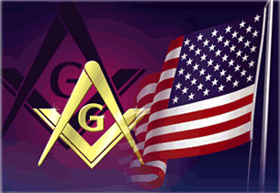
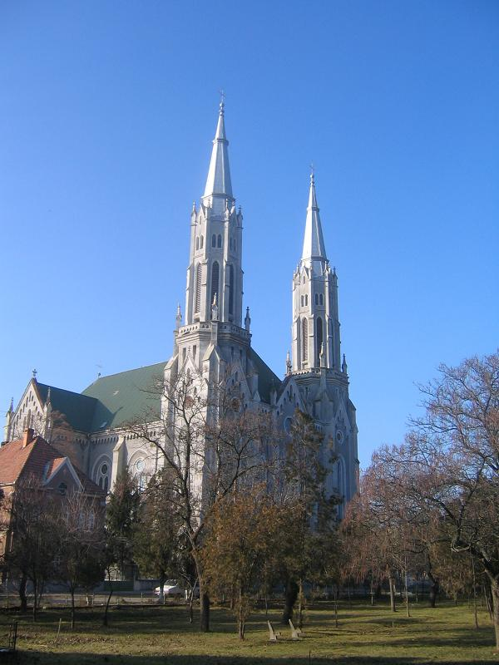
The new world of America was to prove an extremely fertile ground in which Freemasonry could take root. It has been argued that many in the old world of Europe saw in the apparently unspoiled nature of the newly discovered continent an opportunity to establish ideal utopian societies free from the mistakes of the past. As we have seen, Rosicrucianism and its attendant beliefs in perfecting the human soul and working towards an idealised new age of human affairs exerted a powerful influence on the development of Freemasonry. In this sense America, unfettered by the restraints of the Roman Catholic Church, presented enormous scope for the spread and influence of Freemasonic societies. Information on the early growth of Freemasonry in America is sketchy but the movement of people and ide as from Europe clearly meant that it would be inevitable that, at some point, the Craft would be carried there. The first known Freemason to settle in America, one whose membership of the Brotherhood is verifiable by contemporary written records, was a man called John Skene.
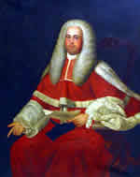

He is thought to have been born around 1649 and his parents Alexander Skene and Lilias Gillespie lived in the English town of Newtyle. Skene is recorded as being a Mason within a lodge in Aberdeen in 1670. In 1682, he emigrated to America where he settled his family on a plantation in New Jersey. Skene appears to have achieved success in his newly adopted country and rose to the rank of deputy colonial governor for West Jersey. However, lack of surviving evidence makes it seem unlikely that Skene created or participated in any Freemasonic activity in America.The first recorded settler born in America who became a Freemason was Andrew Belcher. In 1704, he was inducted into a lodge whilst in England. In 1733 the first American lodge to receive an official warrant from the Grand Lodge of England was St John’s Lodge of Boston.Masonic lodges were also in evidence in America within military lodges of the British Army that conducted their ceremonies and meetings in the field.Benjamin Franklin played a major role in the promotion of Freemasonry in America through his work in newspapers such as the Pennsylvania Gazette. Franklin became a Mason in 1732 and became junior warden of the Pennsylvania Grand Lodge in the same year. It has been argued that the lodge system in America provided a forum for the discussion of views at this time and also served

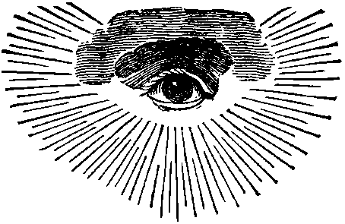
to a great extent as a unifying factor for the colonies. Franklin became an outspoken defender of American rights against the controls of the British government and he would, of course, play a major role in the foundation of the emerging nation.

