Statiunea Mamaia

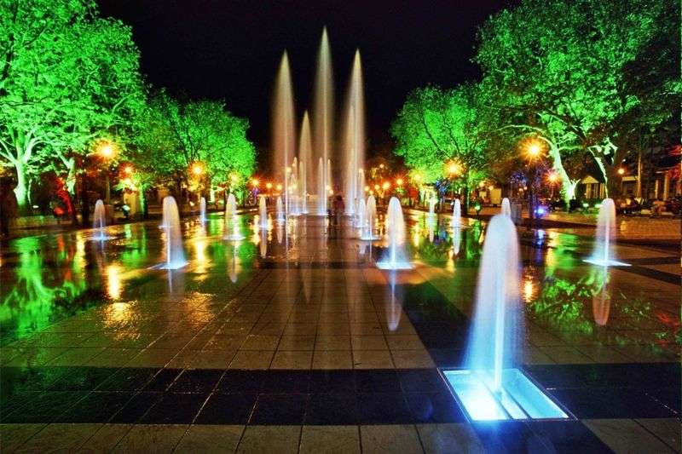

Information about Mamaia
Mamaia is the most famous resort on the Romanian seaside. Located at N Constanta between the Black Sea and Lake Siutghiol, is the season with the largest capacity of accommodation. Mamaia is a resort with a very dynamic development in recent years is building several new hotels, restaurants and shops complex. Every year, tourists were used to the fact that ii Mamaia resort welcomes you with something new - palm trees, Aqua Magic, fountains arteziene, Telegondola, buses etc. supraetajate.
History:
Mamaia was inaugurated in 1906 and soon became the most important tourist destination for tourists from Romania. An important development has experienced in years of communism, when they built more hotels - at the time very modern - Dorna, Bicaz, Siret, Patria, National Union, Miorita. In 1968 was inaugurated the biggest and modern hotel complex, consisting of hotels: Venus, Riviera, Astoria, Metropol, Majestic, Minerva and Mercury, giving a total of 2700 beds. Until 80 years has known moments of glory, became a resort Mamaia frequency and foreigners. After 90 years entered a decline, but lately has become the new "Pearl of the Romanian seaside.
Beach:
Mamaia is only by a very large width and length of beach over 8 km. The beach has fine sand, and the entrance is very water line. In large part the beach is granted and is arranged with sezlonguri and shadows - for a price, but there are large portions of the beach where they can stay without paying. During the summer season, the beach is clean every day.
In patches are installed on the beach lifeguard points. Salvamarii are well trained and ensure daily between the hours of 08.00 - 20.00.
Accommodation and meals:
Mamaia currently offers multiple possibilities of accommodation in hotels and tourist villas from 2 to 5 stars. As in recent years has become small in the months July-August, have built several new hotels, offering services and quality facilities: Hotel Malibu, Hotel Royal, Hotel Florida, Palm Beach Hotel, Hotel Laguna, Hotel Elegance etc.. Some of them are located on the shores of Lake Siutghiol an unexplored area of the resort before. Because the tastes of tourists and claims increase, more and more hotels have arranged space for treatment and relaxation, with pools, saunas, fitness halls, sports.
Terraces and restaurants are numerous, the entire string faleza and offers tourists the opportunity of serving complete meals or individual dishes in two large bathrooms. However, there are some areas that are focused more restaurants: Casino, Holiday Village and Pearl.

