How can you change your hometown?

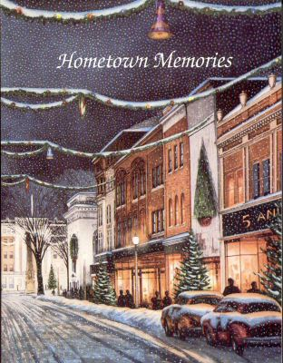

I love my town. I believe it is a very beautiful town. Brasov is an old town, with beautiful landscapes, buildings and full of history.
Our town has gone through a lot of changes lately but the most visible one has been the work that has been done to our roads. All the roads wide or narrow were altered in a certain way lately, to adapt to the huge wave of cars that appeared in the past years.
Our city is old with narrow streets especially in the old city centre. There are not enough parking spaces, the roads are always crowded and this is difficult for drivers and for pedestrians equally.
The sidewalks became naJTower so that the roads can get a second lane. In this way sometimes it's very difficult to walk because the sidewalks become so very crowded.
If I were to change something in this city I would definitely change the way people try to make more space for the cars without taking into consideration the pedestrians, especially in the old part of the town when people go to enjoy the view, to shop, to sit around the fountain in the Council Square, to listen to the concerts organized there.
What would I do? I would restrict the driving access in the city centre, and like in other European cities I would add a road tax for the drivers who want to drive into the city centre. In this way, I think there would be less traffic jams, and we won't end up without sidewalks.
I would also make a bike lane, so that children can enjoy riding their bikes particularly because the bike lane they have in the central park is very narrow and difficult to use.
I totally agree that cars should have their rights in our lives but we should fight against pollution that affects the old buildings and the noise the people who live there have to put up with. When we do something we have to think about all of us, we have to consider all the options, not to see only one side of the coin.

