How to handle money

Is it better to enjoy your money when you-earn it or is it better to save your money for some time in the future? Use specific reasons and examples to support your opinion.

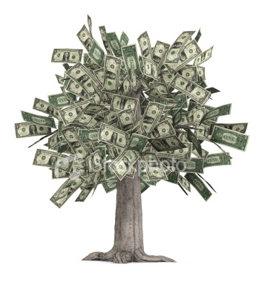

The first payday is a date to remember for the rest of our lives. Earning our own money is very important especially when we are young and need our independence. But also, when we are young we need a lot of things. Therefore, even if we enjoy our first salary we end up thinking is not enough and we should make additional work to have more money so we can buy everything we need. Probably, people are rarely happy with their salary because nowadays we have to buy so much. There are so many things we have never thought about in the past and now we have to have them.
And also, there are too many places to visit, holidays at the seaside or in exotic countries to take, new clubs and restaurants to go to. For all these we need money. So, when to save money or better said what money is there to be saved when our salary is hardly helping us to keep up with our pressing wishes and dreams.
Generally people think, especially when they are young, what for to save money? They will have enough time to save money when they will be older because then they won't need so many things. But this is wrong. Our needs sometimes grow with the age. We get married, have children, our expenses grow and sometimes it's more difficult to put money aside when we are older. At that moment we need to save money for the children for their education, for their needs.
In my opinion we have to think about saving money since we start working. We can make a life insurance or a health insurance, save money into a private pension account or just put a sum of money into a bank account. In this way, whenever we need money we know that there is a place we can go and get them.
There are moments in our lives when we need money and either if we are old or young we have to think about those moments and I believe that it is very useful to have an account for "the rainy days".

