TITANIC


In 1996, treasure hunter Brock Lovett and his team explore the wreck of the RMS Titanic, searching for a necklace set with a valuable blue diamond called the Heart of the Ocean. They discover a drawing of a young woman reclining nude, wearing the Heart of the Ocean, dated the day the Titanic sank. News of this drawing on television attracts the interest of the woman in question, Rose Dawson Calvert, now nearly 101, who informs Lovett that she is the nude woman in the drawing. She and her granddaughter Lizzy visit Lovett on his ship, and she recalls her memories as 17-year-old Rose DeWitt Bukater aboard the Titanic to the somewhat skeptical team. In 1912, young Rose boards the departing ship with the upper-class passengers, her mother, Ruth DeWitt Bukater, and her fiancé, Caledon Hockley. Also on board is Margaret "Molly" Brown, who makes the acquaintance of Rose's party. Distraught and frustrated with her engagement to Cal and her controlled life, Rose attempts to commit suicide by jumping from the stern, but a drifter and artist named Jack Dawson, who had won his ticket on the ship from a poker game, intervenes. Initially Cal, his friends and the sailors, overhearing Rose's screams, believe the penniless Jack attempted to rape her. She explains Jack saved her life, covering up her suicide attempt by explaining she slipped after trying to see the propellers. Jack corroborates her white lie to everyone present, but privately, Hockley's manservant, former police officer Spicer Lovejoy, expresses to Jack his skepticism. Jack and Rose strike up a tentative friendship as she thanks him for his corroboration, and he shares stories of his adventures traveling and sketching; their bond deepens when they leave a first-class formal dinner for a much livelier gathering in third-class.

Cal is informed of her partying in the steerage and forbids Rose to meet Jack again. Rose's mother also commands her to give up Jack and save her engagement to Cal in order to ensure their financial welfare. Eventually, Jack confronts Rose alone, but she is inclined to ignore their growing affection because of her engagement and responsibilities. However, after witnessing a woman encouraging her seven-year-old daughter to behave like a "proper lady" at tea, Rose later changes her mind and decides to offer her heart to Jack in a forbidden romance. As a sign of her affection, she asks him to sketch her nude wearing only the Heart of the Ocean, which she had previously been offered as an engagement present by Cal. Afterwards, the two run away from Lovejoy, and they go below decks to the cargo hold. They enter William Carter's Renault traveling car and have sex, before escaping up to the ship's forward well deck. Rose decides that when they arrive at New York, she will leave the ship with Jack. They then witness the ship's collision 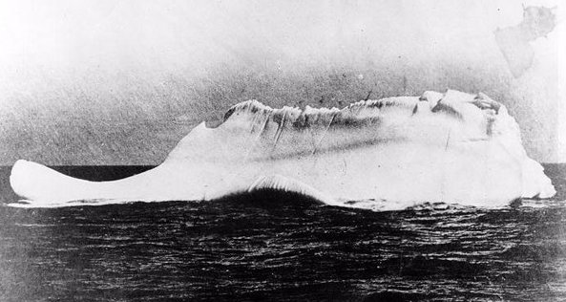with an iceberg, which critically damages it. Meanwhile, Cal discovers Rose's nude drawing and her taunting note in his safe. He plots revenge, deciding to frame Jack for stealing the Heart of the Ocean, and bribes the master-at-arms to handcuff and lock Jack in his office. Although Rose is at first indecisive, she later runs away from Cal, risking her chances of getting on a lifeboat with her mother, in order to find and rescue Jack.
Rose manages to free Jack with a fire axe, and finds that the third-class passengers are trapped below decks. Frustrated, Jack breaks through a gate, allowing Rose and others to make their way to the boat deck. Cal and Jack, though enemies, both want Rose safe and so they manage to persuade Rose to board a lifeboat. But after realizing that she cannot leave Jack, Rose jumps back on the ship and reunites with Jack in the ship's first class staircase. Infuriated, Cal takes Lovejoy's pistol and chases Jack and Rose down the decks and into the first class dining saloon. After running out of ammunition, he angrily shouts at them saying that he hopes "they enjoy their time together" and realizes that he has unintentionally left the diamond in the pocket of an overcoat that Rose is wearing. Hockley returns to the boat deck and gets aboard Collapsible A by pretending to look after an abandoned child. This is one of only two lifeboats remaining on the ship. Although Jack and Rose manage to avoid Cal's fury, they find that the lifeboats are gone. With no other options, they decide to head aft and stay on the ship for as long as possible before it sinks completely. Eventually, the ship breaks in half and begins its final descent, washing everyone into the freezing Atlantic waters. Jack and Rose are separated under the water but shortly reunite. Around them, well over a thousand people are dying painfully from hypothermia.

Meanwhile, in Lifeboat 6, Molly Brown tries to go convince Quartermaster Robert Hichens to go back and rescue people, as there is plenty of room, but he refuses, knowing that there is not enough room for all of them and that all the boats will be swamped. Jack manages to grab hold of a wall paneling, and gets Rose to lie on it. While lying on the wall paneling, Jack makes Rose promise that, whatever happens, she must get out alive. When Fifth Officer Harold Lowe returns with an empty Lifeboat 14 to rescue several people from the water, Rose tries to wake Jack, but then realizes that he has died in the freezing water. Upon this realization, she begins to lose hope and wants to stay there to die with Jack, but remembers her promise. She does her best to call out to Lowe, but she is hoarse and he does not hear her and rows away. Still remembering her promise to "never let go", Rose manages to unclasp Jack's frozen hand from her own, letting his body disappear into the sea. Throwing herself into the water, Rose takes a whistle from a dead Chief Officer Henry Wilde and blows it, and is heard. She is pulled to safety, joining the five other survivors from the water, and is taken on board the rescue ship RMS Carpathia. On the Carpathia's deck, Rose notices Cal coming down searching for her desperately; when he turns in her direction, she turns away and avoids being seen by him thanks to a blanket wrapped around her. This is the last time she ever sees Hockley. Upon arrival in New York City, Rose registers her name as Rose Dawson and presumably starts a life on her own. Through the elderly Rose, we learn that Cal went on to marry another woman, and later committed suicide as a result of business losses in the Great Depression. The subsequent story of Rose's mother, who escaped on a lifeboat and was presumably rescued, is not told. After completing her story to the team (who now look at her with sympathy and awe), the elderly Rose goes alone to the stern of Lovett's ship. After she steps onto the railing, it is revealed that she still has the Heart of the Ocean in her possession. She then drops the diamond into the water, sending it to join the remains of the single most important event of her life. She kept every promise she had made to Jack, and did everything they ever talked about doing. Rose lies in her bed, next to photographs of her life's achievements, as the shot pans across her into darkness. The film ends with a vision of young Rose reuniting with Jack at the Grand Staircase, surrounded by those who perished with Jack. They kiss and embrace, and all the people on the staircase start to applaud. It is left up to the viewer to decide the meaning of the ending: whether Rose is only dreaming or if it is truly a vision of Rose reuniting with her lover in the


Rose's nude drawing

Rose and Jack

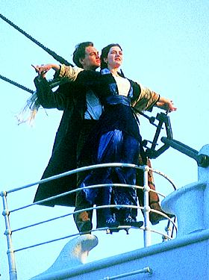
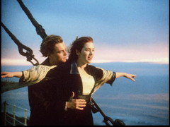

Rose and Jack

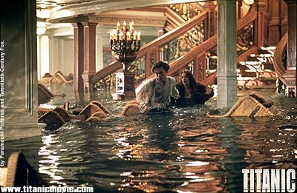

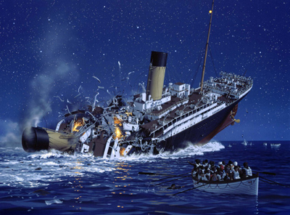

Breaking A part of Titanic

