“Since its invention in 1876 the telephone evolved along with the technology of the time. Not only was there an evolution in the instruments but many different manufacturers produced various styles and a certain uniqueness to their wall and desk telephones”

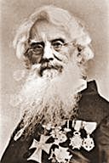
Morse, Samuel Finley Breese (1791-1872), American artist and inventor, known for his invention of the electric telegraph and the Morse code. Morse was born in Charlestown (now part of Boston), Massachusetts, on April 27, 1791, and educated at Yale College (now Yale University). He studied painting in London and became a successful portrait painter and sculptor. In 1825 he helped found the National Academy of Design in New York, and the following year he became the first president of the institution. He continued his painting and became a professor of painting and sculpture at New York University in 1832. At about that time he became interested in chemical and electrical experiments and developed apparatus for an electromagnetic telegraph that he completed in 1836. The following year he filed a caveat, or legal notice, at the Patent Office in Washington, D.C., and tried without success to obtain European patents for his apparatus. He also invented a code, now known as the Morse code, for use with his telegraph instrument.
In 1843 the Congress of the United States appropriated US$30,000 for Morse to construct an experimental telegraph line between Washington, D.C., and Baltimore, Maryland. The line was successfully installed, and on May 24, 1844, Morse sent the first message: “What hath God wrought!” Morse was subsequently involved in much litigation over his claim to the invention of the telegraph, and the courts decided in his favour. He received many honours. Later he experimented with submarine cable telegraphy.
Morse died in New York on April 2, 1872.

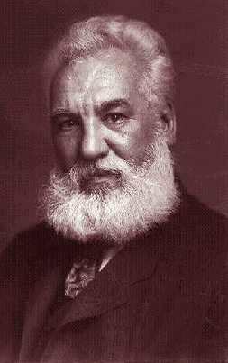
Bell, Alexander Graham (1847-1922), British-born American inventor and teacher of the deaf, most famous for his invention of the telephone. Bell was born on March 3, 1847, in Edinburgh, and was educated at the universities of Edinburgh and London. He emigrated to Canada in 1870 and to the United States in 1871. In the United States he began teaching deaf mutes, publicizing the system called visible speech. The system, which was developed by his father, the Scottish educator Alexander Melville Bell, shows how the lips, tongue, and throat are used in the articulation of sound. In 1872 Bell founded a school for deaf mutes in Boston, Massachusetts. The school subsequently became part of Boston University, where Bell was appointed Professor of Vocal Physiology. He became a naturalized US citizen in 1882.
Since the age of 18 Bell had been working on the idea of transmitting speech. In 1874, while working on a multiple telegraph, he developed the basic ideas for the telephone. His experiments with his assistant Thomas Watson finally proved successful on March 10, 1876, when the first complete sentence was transmitted: “Watson, come here; I want you”. Subsequent demonstrations, particularly one at the 1876 Centennial Exposition in Philadelphia, Pennsylvania, introduced the telephone to the world and led to the organization of the Bell Telephone Company in 1877.
He died on August 2, 1922, at Baddeck, where the Canadian government maintains a museum containing many of his original inventions.

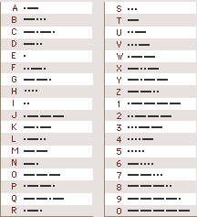
Morse Code, International, system of signals employed in radiotelegraphy in the land-telegraph systems of all countries except the United States and Canada, and by all countries in flash lamp communications in marine navigation. The system is an adaptation of Morse code, the original telegraph alphabet devised by the American inventor Samuel F. B. Morse. When other countries adopted the International Morse Code for sending radiotelegraphy messages in the 1850s, the United States and Canada continued to use the original Morse code. International Morse Code consists of combinations of dots and dashes representing the letters of the alphabet and numerals, as shown in the accompanying table. The duration of one dash equals that of three dots. Today, International Morse Code is rarely used, because radiotelegraphy has been replaced by printing telegraph systems, and facsimile transmission. The international code of signals however, is still used to ensure the safety of navigation and people at sea.

Telephone
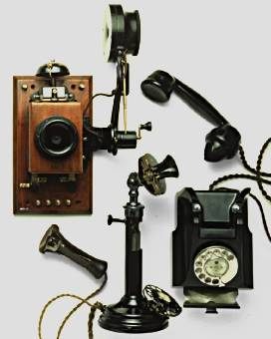
Communication instrument designed to transmit speech and other sounds to a distant point by means of electricity, and to reproduce them.
The telephone contains a diaphragm, which vibrates when struck by sound waves. The vibrations (wave motion) are converted into electrical impulses and transmitted to a receiver, which converts the impulses back into sound.
In common usage, the term “telephone” is also applied in a much broader sense to the entire system to which an individual telephone set is connected; a system which allows the sending of not only a user’s voice but also data, pictures, or any other information which can somehow be encoded and converted into electrical energy. This information is exchanged between points connected to the network. The telephone network consists of all of the transmission paths between subscriber’s sets and of the switching machinery used to select a particular path or group of paths between subscribers.

Parts of a Telephone Set
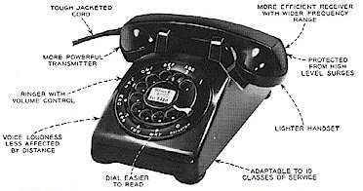
A basic telephone set contains a transmitter, receiver, dial, ringer, and antisidetone network as electrical parts. (This use of the word “network” refers to a small assembly of electrical components inside the set and should not be confused with “network” in “telephone network” which refers to the global interconnected system). If it is a two-piece set, the transmitter and receiver are mounted in the handset, the ringer is typically in the base, and the dial and antisidetone network may be in either the base or handset but are usually together. More sophisticated telephones will have a microphone and speaker in the base in addition to the transmitter and receiver in the handset. In a cordless phone the handset cord is replaced by a radio link between the handset and base but a line cord is still used. A cellular phone is often a one piece unit in which extremely miniaturized components make it possible to combine the base and handset into one handheld unit that communicates with a distant radio station. No line or handset cords are needed, providing the ultimate in portability.
The invention of the carbon telephone transmitter by Emile Berliner was the key to a practical telephone.
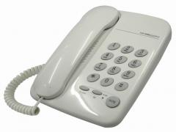
Today, most telephones have pushbuttons instead of a rotary dial. Because Touch Tone was introduced as an optional premium cost service the exchange has to maintain the ability to receive either pulse or multitone dialing. Since a person buying a telephone might have a line on which multifrequency signals are not accepted by the telephone company, pushbutton telephones usually have a switch which the customer can set to determine whether the telephone will send pulses or tones.

Transoceanic Telephony
Overseas radio-telephone service was introduced commercially in 1927, but the problem of amplification prevented the laying of telephone cables until 1956, when the world’s first transoceanic submarine telephone cable, extending between Newfoundland and Scotland, was placed in service.
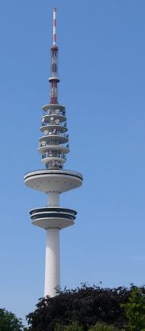

Microwave Relay

In this method of transmission, radio waves generally in the superhigh-frequency band, called microwaves, are relayed from station to station. Because the transmission of microwaves requires a clear line of sight between sending and receiving stations, the average distance between relay stations is about 40 km (25 mi). As many as 600 telephone conversations can be transmitted over one microwave relay channel.

Satellite Telephony
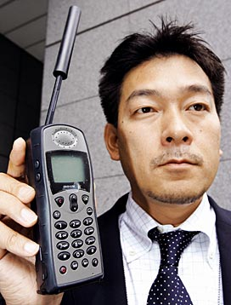
In 1969 the first global telephone relay network was completed with a series of satellites in stationary orbits 35,880 km (22,300 mi) above the Earth. These satellites are powered by solar energy cells. Calls transmitted from an Earth antenna are amplified and retransmitted to distant ground stations. The integration of satellite and terrestrial facilities allows calls to be routed between continents as easily as between domestic points. Thanks in large part to digitization of transmissions, satellites of the global Intelsat series can relay up to 33,000 calls simultaneously as well as several television channels.
One satellite would not serve for a call from New York to Hong Kong, for example, but two would. Even considering the expense of a satellite such a path is cheaper to install and maintain per channel than the equivalent path using coaxial cables on the ocean floor. Consequently, as much use is made as possible of satellite links in long distance.
Satellites do have one serious shortcoming, however. Because of the satellite’s distance and the finite speed of radio waves, there is a noticeable lag in conversational responses. Because of this, many calls will only use a satellite for one direction of transmission (say from New York to San Francisco) and will use a ground microwave or coaxial link for the opposite direction. The participants in a call from New York to Hong Kong might be annoyed if carried over a two satellite link in both directions because they would find it difficult to interrupt—which is a normal occurrence in speech. They would also be bothered by the long time (over a second) it took the other party to respond after each had finished speaking.

Video Telephone

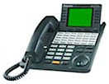
A two-way video telephone was first demonstrated in 1930 by the American inventor Herbert Eugene Ives in New York. The video telephone can be linked with a computer for displaying reports, charts, and schedules over long distances. It also enables face-to-face meetings of callers in different cities and can serve as a link between conference centers in a network of major cities. Video telephones are now commercially available and can be used on domestic lines for face-to-face calls. Similar features are also now viable between suitably equipped personal computers.

Cellular Mobile Communication

Cellular, or mobile phones, originally used in cars, airliners, and passenger trains, but increasingly becoming ubiquitous, are basically low-power radio-telephones. Calls go through radio transmitters that are located within small geographical units called cells. Because each cell’s signals are too weak to interfere with those of other cells operating on the same frequencies, more channels can be used than would be possible with high-power radio frequency transmission. Narrow-band frequency modulation (FM) is the most common mode of transmission, and each message is assigned a carrier unique to the cell from which it is transmitted. Since the cellular phone was first tested in 1978, the cellular market in Britain alone had grown at a rapid rate to over 8.5 million users by 1997. In Japan it is as high as one mobile phone per ten people. However, while the number of cellular users has increased, many new subscribers are low users. In the United Kingdom cable operators are gaining some 500,000 extra subscribers per month.

Voice Mail
Voice mail allows incoming messages to be recorded for later playback when the call is not answered. In advanced forms of voice mail the user may record a message to be sent later in the day.
For residential service voice mail can either be purchased from the telephone company as an exchange-based service or it is available by purchasing an answering machine. This usually contains a regular telephone set along with a recording, playback, and automatic ring detection capability. If an incoming call is answered at any telephone on the line before a pre-set number of rings, the answering machine does nothing. However, after the pre-set number of rings, the answering machine goes off hook and plays a pre-recorded message stating that the owner cannot answer the phone now and inviting the caller to leave a message to be recorded.
The answering machine’s owner is alerted to the presence of a recorded message by a light or audible “beep” and can retrieve the message later. Most answering machines and all exchange-based services also allow the owner to retrieve recorded messages from a remote location by dialing a code after the machine has answered.

Bibliography:
- “Meyer, Ralph, Old-Time Telephones! Design, History, and Restoration, 2nd Edition (now includes AE phones), Atglen, Pennsylvania: Schiffer Publishing Ltd., 2005”
- “Dooner, Kate, Telephones Antique to Modern, West Chester, Pennsylvania: Schiffer Publishing, Ltd., 1992”
- “Microsoft Encarta Interactive World Atlas 2008”
- “Wikipedia the free encyclopedia"

