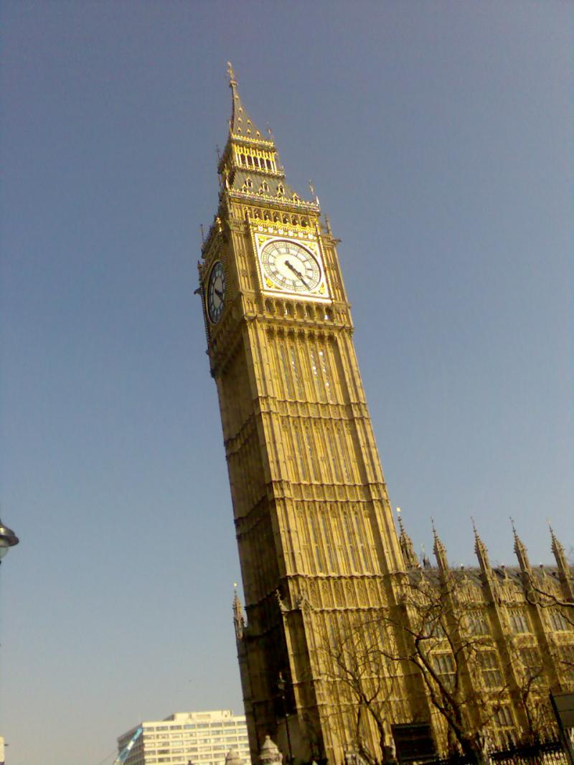
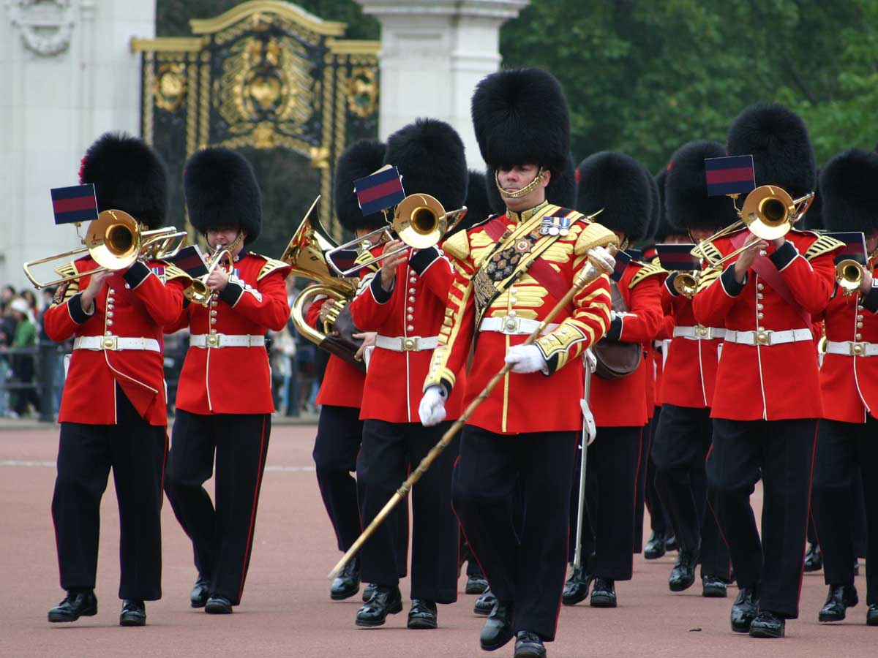

During the summer, the Changing of the Guard takes place at the front of the Palace and is a popular event for visitors to the capital from 1st April to Early July and on alternate days at other times.
Since 1660, Household Troops have guarded the Sovereign and the Royal Palaces. The Queen's Guard usually consists of Foot Guards in full-dress uniform of red tunics and bearskins.
The Changing of the Guard takes place in the forecourt of Buckingham Palace at 11.30 every day in summer, every other day in winter, and lasts about 45 minutes. The New Guard marches to the Palace from Wellington Barracks with a Guards band, the Old Guard hands over in a ceremony during which the sentries are changed and then returns to barracks. The New Guard then marches to St James's Palace leaving the detachment at Buckingham Palace.

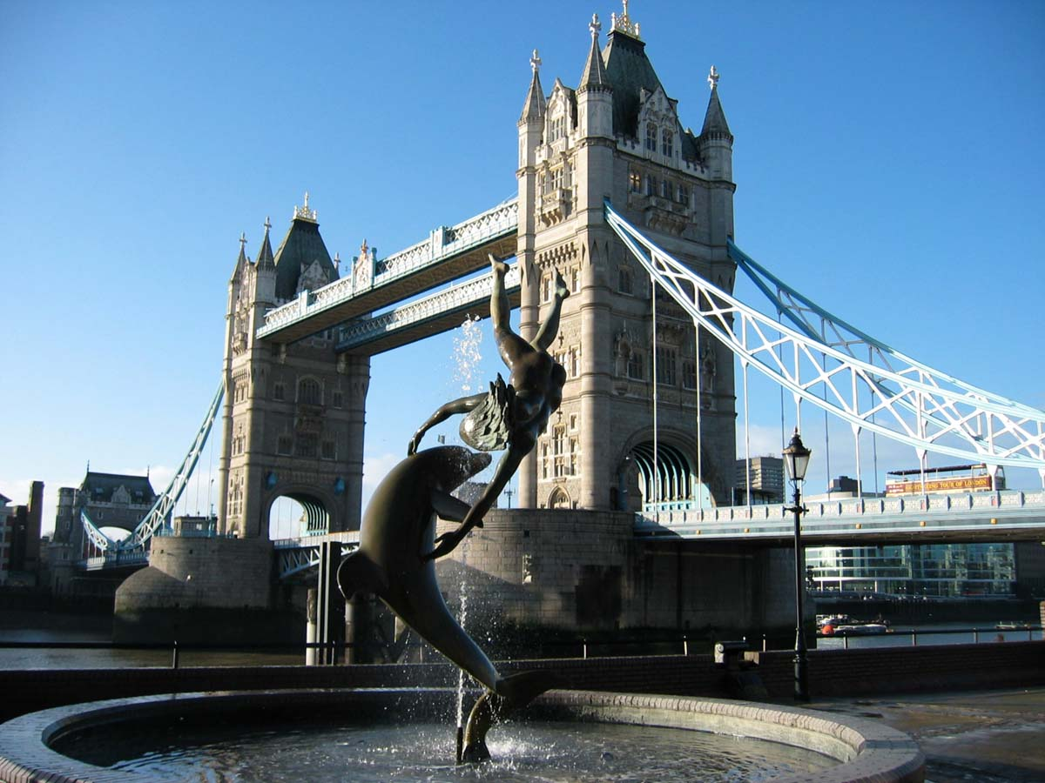

On this photo we can see One of the most famous arhitectural creation in United Kingdom. The london’s Tower Bridge was build in 1894 year other the Thames river. Here we also see the cars that across this Bridge every day, and a beautyfull statue on the first plan. Worth a visit on Tower Bridge is the Tower Bridge Exhibition Centre. From the exhibition centre you enjoy high-level Walkways, learn about the history of Tower Bridge and tour the Victorian Engine Rooms.
Tower Bridge opens at the centre to allow larger ships to pass down the River Thames and is known as a “bascule bridge”. The power to lift bridge was originally supplied by steam engines but the power is now supplied by oil and. The original pumping engines, accumulators and boilers are on show as part of the Tower Bridge Exhibition. In 1977 Tower Bridge was painted red, white and blue to celebrate the Queen's Silver Jubilee.
The Bridge is actually in two different postcodes, the North end being in E1 and the South end being in SE1.

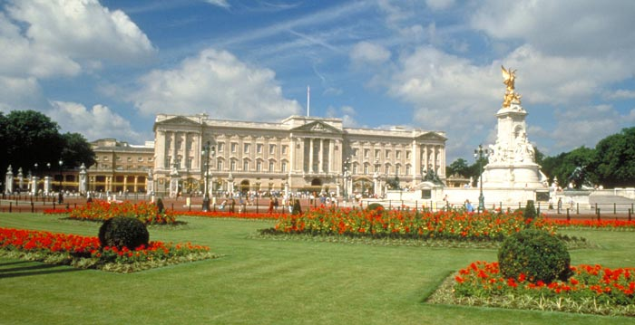

Buckingham Palace has been the official residence of seven generations of British monarchs from 1837 to the present reigning House of Windsor and is today The Queen's official residence .
When the Queen is in residence the Royal Standard can be seen flying above the palace.

It has become the symbol of the Royal Family.
But this Palace is more than a home for the Royals.
It is the official administrative headquarters of the monarchy and contains the offices of their staff.
It is the place where all Royal ceremonies and official banquets are held.
The palace contains 19 state rooms, 52 royal and guest bedrooms, 188 staff bedrooms, 92 offices, and 78 bathrooms.
Although in use for the many official events and receptions held by The Queen, 19 rooms of the Palace are opened to visitors during the Annual Summer Opening in August and September to help raise funds to repair fire-damaged Windsor Castle

Thinking of joining the ranks of the greatest photographers of all time? Well, it might be a good idea to check out a few of them and the works they've done so you know just what it is you're up against.
Probably one of the most famous photographers of all time was Ansel Adams. Adams was born In San Francisco California in 1902. He lived in Carmel until he died in 1984. His most popular photo was titled "Moonrise Over Hernandez, 1944". This is a breathtaking photo showing a beautiful night view and the small town below it. Other famous photos by Adams were "Clearing Winter Storm" and "Winter Sunrise". Adams did a lot of outdoor photography with some breathtaking views. His most popular photo has about 1000 copies in print. The price range of these photos, depending on condition goes from $5,000 to $175,000 if you can find one.
Moving from outdoor photography of landscapes to nude women on beaches we have the works of Jock Sturges. Sturges was born in the big city of New York in the year 1947. He currently lives in Seattle, Washington. His most popular images, all of beach nudes, are "Misty Dawn 1991" and "Northern California, 1991". His prints range in price from $1,000 to $3,000. His most expensive print sold for $4,000.
Herman Leonard was known for taking great photographs of jazz legends. He was born in Allentown, PA in 1923. He currently lives and works in New Orleans. His most popular images are photos of great jazz legends Dexter Gordon, Duke Ellington, Frank Sinatra, Miles Davis, Louis Armstrong and Billie Holiday. Herman Leonard was one of the more active photographers even when not working at his craft. He often traveled with great entertainers like Marlon Brando, who he hung out with in 1954. His photos range in price from $950 to $5,500.
Another great photographer was Irving Penn who was born in Plainfield, NJ in 1917. Penn was actually known for a number of different styles of photography including fashion photography and provocative life style portraits. His most famous work was "Cuzco Children" which sold for as much as $175,000 at the turn of the century. Penn worked for some of the most popular magazines of our time including Harper's Bazaar, Saks Fifth Avenue and Vogue Magazine.
Another great photographer, who most people have actually heard of, was the one and only Helmut Newton, who just recently passed away in 2004. He was most known for photos involving fashion and nudes illustrating themes of mass media, glamour, sex and theater. Newton's work was often categorized as bizarre. He was once quoted as saying "My job as a portrait photographer is to seduce, amuse and entertain". He most certainly did that better than just about anyone else. His most popular image is "Sie Kommen I, II". His photographs are in such demand that some go for as much as $400,000 each.

