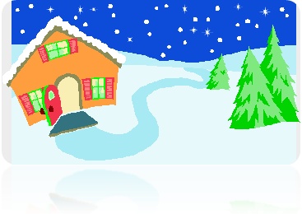
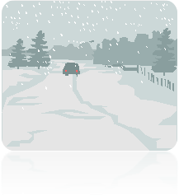

Winter

It’s winter! Outside is snowing. Children are very happy because outside is beautiful . Some children are making a snowmen and others are sleighing through the snow. The Christmas is coming and we are all preparing for it . The trees are charged with snow and look like silver trees . The snowflakes are big . Me, Giovanna and Mary are going to make a big snowman . We are waiting for Santa Clause , who is coming with many presents . Mothers are making food for Christmas . Neighbours disect the pigs .Christmas is expected very much by children because they like singing carols . The snow is very big . Some boys are going with their fathers to buy Christmas trees . All mothers are with their girls buying balls , garlands and other objects to decorate the Christmas tree and make food . The wonderful Chirstmas is coming .
Winter is a beautyful season!

