Great people who influenced the world
1. Albert Einstein

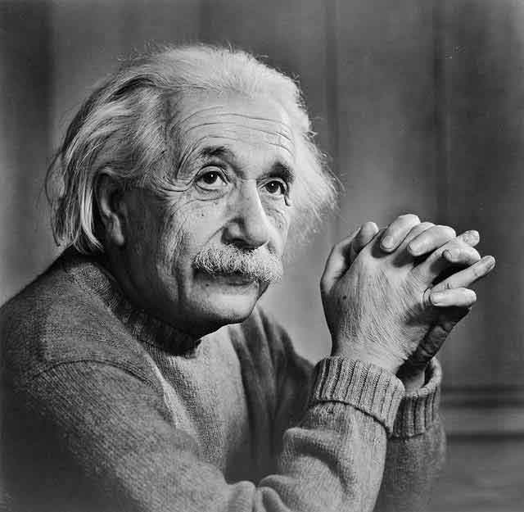
Albert Einstein (March 14, 1879 – April 18, 1955) was a German-born American theoretical physicist who is widely regarded as the greatest scientist of the 20th century. He proposed the theory of relativity and also made major contributions to the development of quantum mechanics.
After graduating in the faculty of Physics, he starts to work at Swiss patent office in Berna. In that period of time he discovers the theory of photoelectric effect and the theory of relativity.
After the start of the Second World War, he moved to USA. There, he helped creating the atomic bomb.
He was a wonderful man, who thought creating atomic bomb will bring peace to man kind. After disaster at Hiroshima he realized he did a big mistake and fought for global peace.He also loved students and helped them to create their own way in life.

2. Alexander the Great
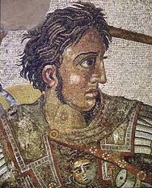
Alexandros III Philippou Makedonon (Alexander the Great, Alexander III of Macedon) (356-323 B.C.), King of Macedonia, was born in late July 356 BC in Pella, Macedonia, he was one of the greatest military genius in history.
He conquered much of what was then the civilized world, driven by his divine ambition of the world conquest and the creation of a universal world monarchy. He was the first great conqueror who
reached Greece, Egypt, Asia Minor, and Asia up to western India.
He is famous for having created the ethnic fusion of the
Macedonians and the Persians.

3.Wolfgang Amadeus Mozart

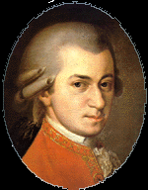
Wolfgang Amadeus Mozart (January 27, 1756-December 5, 1791) is considered one of the greatest musical geniuses of all time, authoring over 600 works before his premature death at 35.
Mozart showed remarkable musical aptitude early in life. Recognizing his enormous talent, his father devoted most of his time to his son's musical education, and taking him on concert tours throughout Europe.
In his rest of life, Mozart made his living performing and selling his compositions and giving music lessons. But, despite his musical talent he had difficulty earning sufficient income to support a family. He died in poverty.
Mozart excelled at nearly every kind of musical composition.
He wrote 22 operas, over 40 symphonies, and many others compositions. Much of Mozart's work is still performed and enjoyed today.

4.William Shakespeare

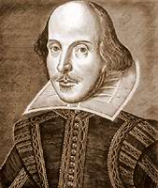
William Shakespeare (baptized 26 April 1564 – 23 April 1616) was an English poet and playwright, now widely regarded as the greatest writer in the English language and the world's preeminent dramatist. He is often called England's national poet and the "Bard of Avon" (or simply "The Bard"). His surviving works consist of 38 plays, 154 sonnets, two long narrative poems, and several other poems created between 1591-1593. His plays have been translated into every major living language and are performed more often than those of any other playwright.
Amazingly, no original manuscripts survive reflecting the fact that many of these manuscripts were written purely for performance and were not regarded as pieces of literary work. There is also no general consensus on when all the plays were first performed.

