AUSTRALIA

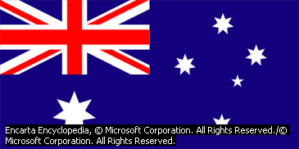

Australia, island continent located southeast of Asia and forming, with the nearby island of Tasmania, the Commonwealth of Australia, a self-governing member of the Commonwealth of Nations.

The Commonwealth of Australia is made up of six states—New South Wales, Queensland, South Australia, Tasmania, Victoria, and Western Australia—and two territories—the Australian Capital Territory and the Northern Territory.

The first inhabitants of Australia were the Aboriginal people, who migrated to the continent some 50,000 to 60,000 years ago. The continent remained relatively unknown to most of the outside world until the 17th century. The first permanent European settlement was established in 1788 at Port Jackson, in southeastern Australia, as a British penal colony; it grew into the city of Sydney. Australia developed as a group of British colonies during the 19th century, and in 1901 the colonies federated to form a unified independent nation, the Commonwealth of Australia.

The climate of Australia varies greatly from region to region, with a tropical climate in the north, an arid or semiarid climate in much of the interior, and a temperate climate in the south. Despite these variations, the moderating influence of the surrounding oceans and the absence of extensive high mountain ranges help prevent marked extremes of weather. However, some areas occasionally experience extreme weather conditions, such as tropical cyclones, tornadoes, and severe drought.

The major cities of Australia are Sydney, a seaport and commercial center; Melbourne, a cultural center; Brisbane, a seaport; Perth, a seaport on the western coast; and Adelaide, an agricultural center. Canberra, the national capital, is much smaller in population.

The United Kingdom and Ireland were traditionally the principal countries of origin for the majority of immigrants to Australia, reflecting the colonial history of the country. Since World War II (1939-1945), however, Australia’s population has become more ethnically diverse as people have immigrated from a wider range of countries. The proportion of residents born in other countries increased from 10 percent in 1947 to 24 percent in 2000.
Great Barrier Reef, world’s largest coral reef system, located off the northeastern coast of Australia bordering the Coral Sea (part of the Pacific Ocean). The reef extends about 2,010 km (about 1,250 mi) roughly parallel to the coast of the state of Queensland, from the Torres Strait in the north to near the town of Bundaberg in the south.

Simple marine animals called corals constructed the Great Barrier Reef over thousands of years. Nearly 3,000 individual coral reefs and some 300 small coral islands form the reef, which ranks as the world’s largest structure made by living organisms. This intricate network of coral formations has an area of about 37,000 sq km (about 14,300 sq mi), encompassing about 13 percent of the world’s total coral reef.
In 1975 the Great Barrier Reef Marine Park was established as the largest marine protected area in the world. The park covers some 344,800 sq km (133,100 sq mi), including waters surrounding the reefs. In 1981 the park was designated a World Heritage Area by the World Heritage Committee of the United Nations Educational, Scientific and Cultural Organization (UNESCO). The Great Barrier Reef is considered one of the great natural wonders of the world.
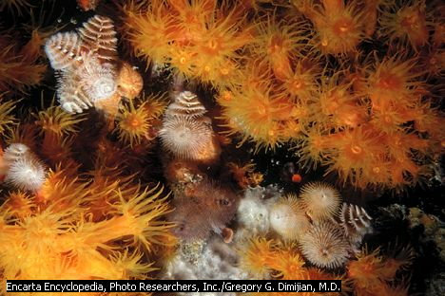
Coral reefs provide the ideal conditions for marine life. They are found in shallow tropical waters that stay warm year-round. Their exposure to sunlight provides energy to the algae and plants that feed animals living in the reef. The reef itself provides creatures with a large, intricate surface area on which they can find food and shelter. For these reasons, more animal species are found on coral reefs than in any other marine ecosystem (localized group of interdependent organisms and the environment they inhabit). Although the coral reefs in Indonesia and the Philippines contain the greatest numbers of species, the Great Barrier Reef also has tremendous numbers of plants and animals.
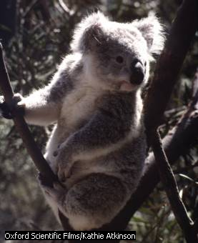
Koala
Most of Australia’s native mammals are marsupials, including the koala. Koalas live in the eucalyptus forests of eastern Australia, where they feed on the leaves and flowers of certain species of eucalyptus, as well as on mistletoe and box leaves.
Other plant and animal life in the reef includes 500 kinds of algae, 4,000 types of mollusks, and 20 species of sea snakes. The Great Barrier Reef Marine Park is an important refuge for a number of threatened species, including 30 species of whales and dolphins, 6 species of sea turtles, the dugong (sea cow), and giant clams.
One of the most spectacular events on the Great Barrier Reef occurs once a year when the coral colonies spawn. For a few nights after the full moon in November or December, all corals of the same species release their eggs and sperm at the same time, with remarkable precision. By spawning all at once, the corals increase the number of their offspring and the chances that at least some will survive.
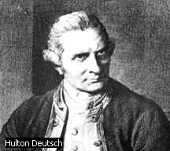
Captain James Cook
British explorer and navigator Captain James Cook sailed around the world twice, made three voyages to the Pacific Ocean, and became the first European to visit Hawaii. Cook sailed to Tahiti, New Zealand, Australia, Vancouver Island, and the Hawaiian Islands, where he was killed in a fight with islanders.

