The seven wonders of the world

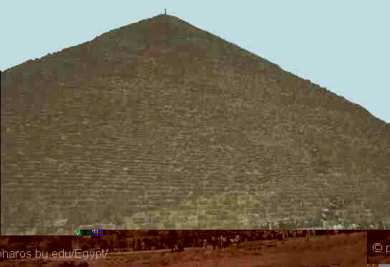
The Pyramids are architectural
monuments of the Egyptian world
which were built by Keops,Kephren,
and Mykerinos,and are considered
to be one of the seven wonders
of the world.

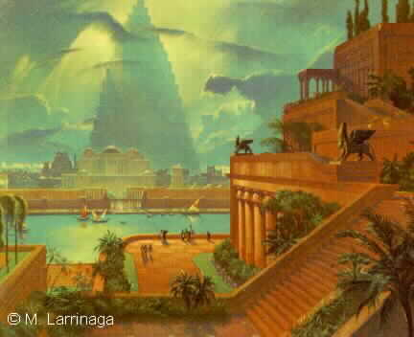
Suspended Gardens of Seramide
were built by Seramida
the legendary queen of Babylon.

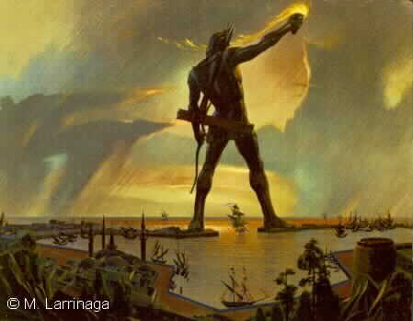
The Colossus of Rhodos was a huge
bronze statue which Represents Helios
the God of the Sun and was built at
The beginning of the 3rd century B.C.

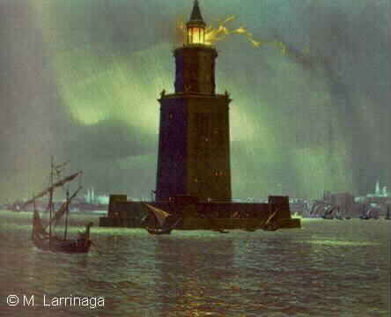
The beacon of Alexandria was buil
in the 3rd centuryB.C.Between the 12th
and the 13th century,due to Earthquakes
it was destroyed.

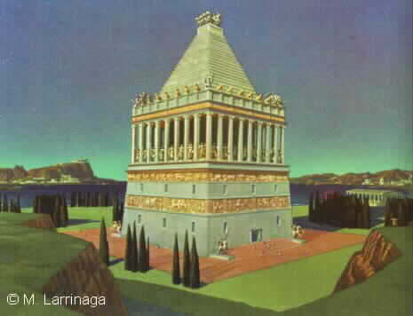
The Mausoleum from Halicarnas is the
grave of MausolThe king of the ancient
Caria.Built at Halicarnas,it was
Started by Mausol and was finished by
Artemisa,his Wife.

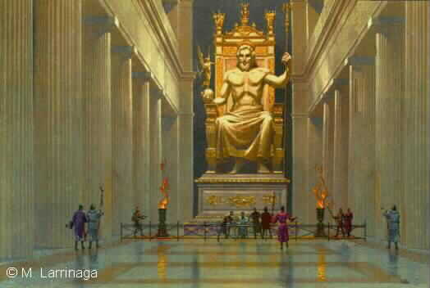
The Statue of Zeus from Olympia was
made by Fidias.
It is placed in the Great Temple of Olympia.
The statue Was destroyed in
the 4th century A.C.

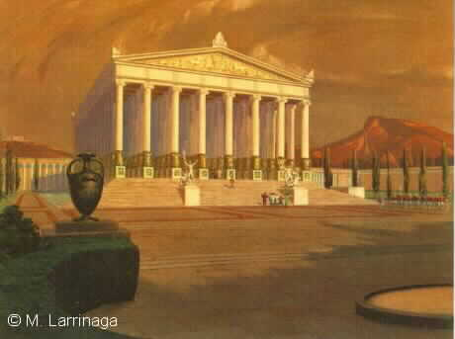
The Temple of Goddess Artemis from Efes.
Started in The 7th century B.C. and finished
in the 4th century B.C.,the temple had one
hundred and twenty-seven Columns.It was
destroyed during the 4th and 6th Centuries A.C.

