Diana, Princess of Wales
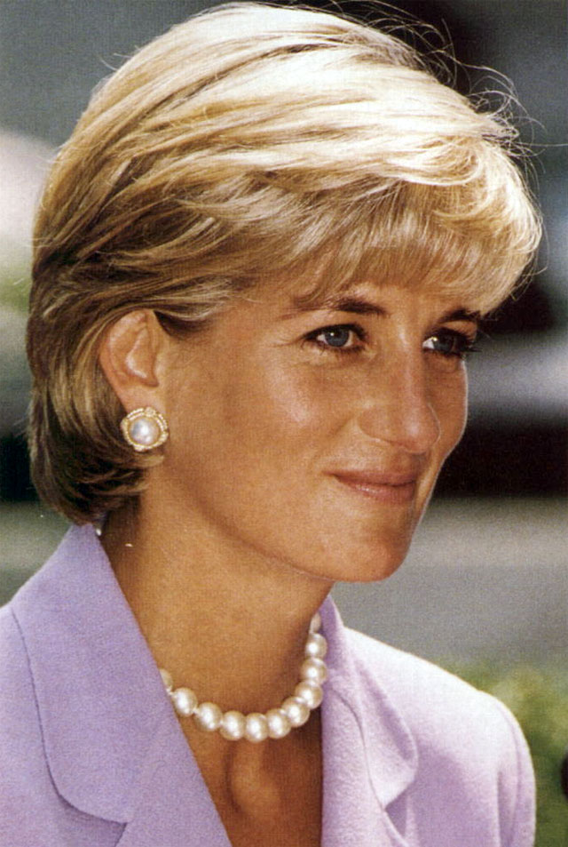
The Lady Diana Frances Spencer (Diana Frances Mountbatten-Windsor, née Spencer) (1 July 1961–31 August 1997) was the first wife of Charles, Prince of Wales. From her marriage in 1981 to her divorce in 1996 she was styled Her Royal Highness The Princess of Wales. After her divorce in 1996, Diana ceased to be a Royal Highness and The Princess of Wales and instead was styled Diana, Princess of Wales. She was often called Princess Diana by the media and the public, but this was incorrect both during and after her marriage, as she was only ever a Princess by marriage, not by birth.'
An iconic presence on the world-stage, Diana, Princess of Wales was noted for her pioneering charity work. Yet her philanthropic endeavours were overshadowed by her scandal-plagued marriage to Prince Charles. Her bitter accusations via friends and biographers of adultery, mental cruelty and emotional distress visited upon her riveted the world for much of the 1990s, spawning books, magazine articles and television movies.
From the time of her engagement to the Prince of Wales in 1981 until her death in a car accident in 1997, the Princess was arguably the most famous woman in the world, the pre-eminent female celebrity of her generation: a fashion icon, an image of feminine beauty, admired and emulated for her high-profile involvement in AIDS issues and the international campaign against landmines. During her lifetime, she was often referred to as the most photographed person in the world. To her admirers, The Princess of Wales was a role model — after her death, there were even calls for her to be nominated for sainthood — while her detractors saw her life as a cautionary tale of how an obsession with publicity can ultimately destroy an individual.
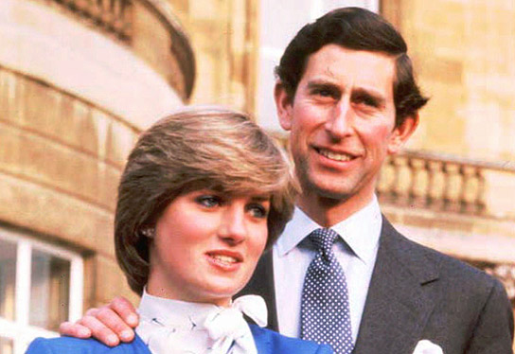
Early years
The Honourable Diana Frances Spencer was born as the youngest daughter of Edward Spencer, Viscount Althorp, and his first wife, Frances Spencer, Viscountess Althorp (formerly the Honourable Frances Burke Roche) at Park House on the Sandringham estate. She was baptised at St. Mary Magdalene Church in Sandringham, by Rt. Rev. Percy Herbert (rector of the church and former Bishop of Norwich and Blackburn); her godparents included John Floyd (the chairman of Christie's) and Mary Colman (a niece of the Queen Mother). Partially American in ancestry — a great-grandmother was the American heiress Frances Work — she was also a descendant of King Charles I.
During her parents' acrimonious divorce over Lady Althorp's adultery with wallpaper heir Peter Shand Kydd, Diana's mother sued for custody of her children, but Lord Althorp's rank, aided by Lady Althorp's mother's testimony against her daughter during the trial, meant custody of Diana and her brother was awarded to their father. On the death of her paternal grandfather, Albert Spencer, 7th Earl Spencer, in 1975, Diana's father became the 8th Earl Spencer, and she acquired the courtesy title of The Lady Diana Spencer and moved from her childhood home at Park House to her family's sixteenth-century ancestral home of Althorp. A year later, Lord Spencer married Raine, Countess of Dartmouth, the only daughter of the romance novelist Barbara Cartland, after being named as the "other party" in the Earl and Countess of Dartmouth's divorce.
Diana was educated at Riddlesworth Hall in Norfolk and at West Heath Girls' School (later reorganized as the New School at West Heath, a special school for boys and girls) in Sevenoaks, Kent, where she was regarded as an academically below-average student, having failed all of her O-level examinations. In 1977, aged 16, she left West Heath and briefly attended Institut Alpin Videmanette, a finishing school in Rougemont, Switzerland (Diana's future husband was also dating her sister, Lady Sarah at that time). Diana was a talented amateur pianist, excelled in sports and reportedly longed to be a ballerina.
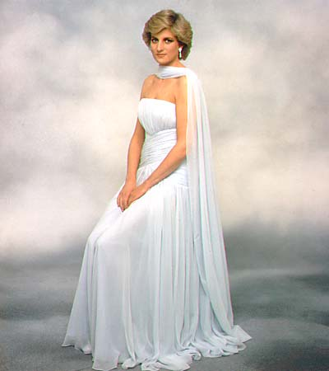
Family and Marriage
Diana's family, the Spencers, had been close to the British Royal Family for decades. Her maternal grandmother, Ruth, Lady Fermoy, was a longtime friend of, and a lady-in-waiting to Queen Elizabeth the Queen Mother.
The Prince's love life had always been the subject of press speculation, and he was linked to numerous women. Nearing his mid-thirties, he was under increasing pressure to marry. In order to gain the approval of his family and their advisors, including his great-uncle Lord Mountbatten of Burma, any potential bride had to have an aristocratic background, could not have been previously married, should be Protestant and, preferably, a virgin. Diana fulfilled all of these qualifications.
Reportedly, the Prince's former girlfriend (and, eventually, his second wife) Camilla Parker Bowles helped him select the 19-year-old Lady Diana Spencer as a potential bride, who was working as an assistant at the Young England kindergarten in Pimlico. Buckingham Palace announced the engagement on 24 February 1981. Mrs. Parker Bowles had been dismissed by Lord Mountbatten of Burma as a potential spouse for the heir to throne some years before, reportedly due to her age (16 months the Prince's senior), her sexual experience, and her lack of suitably aristocratic lineage.
The wedding took place at St Paul's Cathedral in London on Wednesday 29 July 1981 before 3,500 invited guests (including Mrs. Parker Bowles and her husband, a godson of Queen Elizabeth the Queen Mother) and an estimated 1 billion television viewers around the world. Diana was the first Englishwoman to marry an heir to the throne since 1659, when Lady Anne Hyde married the Duke of York and Albany, the future King James II. Upon her marriage, Diana became Her Royal Highness The Princess of Wales and was ranked as the most senior royal woman in the United Kingdom after the Queen and the Queen Mother.
The Prince and Princess of Wales had two children, Prince William of Wales on 21 June 1982 and Prince Henry of Wales (commonly called Prince Harry) on 15 September 1984.
After the birth of Prince William, the Princess of Wales suffered from post-natal depression. She had previously suffered from bulimia nervosa, which recurred, and she made a number of suicide attempts. In one interview, released after her death, she claimed that, while pregnant with Prince William, she threw herself down a set of stairs and was discovered by her mother-in-law (that is, Queen Elizabeth II). It has been suggested she did not, in fact, intend to end her life (or that the suicide attempts never even took place) and that she was merely making a 'cry for help'. In the same interview in which she told of the suicide attempt while pregnant with Prince William, she said her husband had accused her of crying wolf when she threatened to kill herself. It has also been suggested that she suffered from borderline personality disorder.
In the mid 1980s her marriage fell apart, an event at first suppressed, but then sensationalised, by the world media. Both the Prince and Princess of Wales spoke to the press through friends, accusing each other of blame for the marriage's demise. Charles resumed his relationship with Camilla Parker Bowles, whilst Diana became involved with James Hewitt and possibly later with James Gilbey, with whom she was involved in the so-called Squidgygate affair.
She later confirmed (in a television interview with Martin Bashir) the affair with her riding instructor, James Hewitt. (Theoretically, such an affair constituted high treason by both parties.) Another alleged lover was a bodyguard assigned to the Princess's security detail, although the Princess adamantly denied a sexual relationship with him. After her separation from Prince Charles, Diana was allegedly involved with married art dealer Oliver Hoare, rugby player Will Carling as well as heart surgeon Hasnat Khan before finally becoming involved with Dodi Fayed.
The Prince and Princess of Wales were separated on 9 December 1992; their divorce was finalised on 28 August 1996. The Princess lost the style Her Royal Highness and the title The Princess of Wales and instead was styled as Diana, Princess of Wales, However, at that time, and to this day, Buckingham Palace maintains, since the Princess was the mother of the second and third in line to the throne, she was officially a member of the Royal Family.
In 2004, the American TV network NBC broadcast tapes of Diana discussing her marriage to the Prince of Wales, including her description of her suicide attempts. The tapes were in the possession of the Princess during her lifetime; however, after her death, her butler took possession, and after numerous legal wranglings, they were given to the Princess's voice coach, who had originally filmed them. These tapes have not been broadcast in the United Kingdom.
Charity work
Starting in the mid-to-late 1980s, the Princess of Wales became well known for her support of charity projects, and is credited with considerable influence for her campaigns against the use of landmines and helping the victims of AIDS.
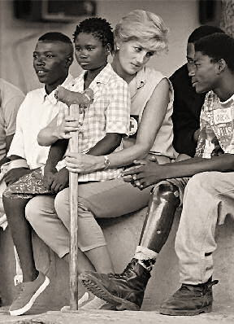
AIDS
In April 1987, the Princess of Wales was the first high-profile celebrity to be photographed knowingly touching a person infected with the HIV virus. Her contribution to changing the public opinion of AIDS sufferers was summarised in December 2001 by Bill Clinton at the 'Diana, Princess of Wales Lecture on AIDS', when he said:
In 1987, when so many still believed that AIDS could be contracted through casual contact, Princess Diana sat on the sickbed of a man with AIDS and held his hand. She showed the world that people with AIDS deserve no isolation, but compassion and kindness. It helped change world opinion, and gave hope to people with AIDS with an outcome of saved lives of people at risk.
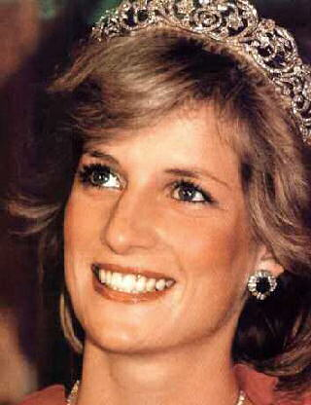
Landmines
Perhaps her most widely publicised charity appearance was her visit to Angola in January 1997, when, serving as an International Red Cross VIP volunteer, she visited landmine survivors in hospitals, toured de-mining projects run by the HALO Trust, and attended mine awareness education classes about the dangers of mines immediately surrounding homes and villages.
The pictures of Diana touring a minefield, in a ballistic helmet and flak jacket, were seen worldwide. (In fact, mine-clearance experts had already cleared the pre-planned walk that Diana took wearing the protective equipment.) In August that year, she visited Bosnia with the Landmine Survivors Network. Her interest in landmines was focused on the injuries they create, often to children, long after the conflict has finished.
She is widely acclaimed for her influence on the signing by the governments of the UK and other nations of the Ottawa Treaty in December 1997, after her death, which created an international ban on the use of anti-personnel landmines. Introducing the Second Reading of the Landmines Bill 1998 to the British House of Commons, the Foreign Secretary, Robin Cook, paid tribute to Diana's work on landmines:
All Honourable Members will be aware from their postbags of the immense contribution made by Diana, Princess of Wales to bringing home to many of our constituents the human costs of landmines. The best way in which to record our appreciation of her work, and the work of NGOs that have campaigned against landmines, is to pass the Bill, and to pave the way towards a global ban on landmines.
As of January 2005, Diana's legacy on landmines remained unfulfilled. The United Nations appealed to the nations which produced and stockpiled the largest numbers of landmines (China, India, North Korea, Pakistan, Russia and the United States) to sign the Ottawa Treaty forbidding their production and use, for which Diana had campaigned. Carol Bellamy, Executive Director of the United Nations Children's Fund (UNICEF), said that landmines remained "a deadly attraction for children, whose innate curiosity and need for play often lure them directly into harm's way".
Death
On 31 August 1997 Diana was involved in a car accident in the Pont de l'Alma road tunnel in Paris, along with her friend and lover Dodi Fayed, and their driver Henri Paul. Fayed's bodyguard Trevor Rees-Jones is the only person who survived the wreckage.
Circumstances
Late in the evening of Saturday 30 August, Diana and Fayed departed the Hôtel Ritz in Place Vendome, Paris, and sped along the north bank of the Seine. Shortly after midnight on 31 August, their Mercedes-Benz S 280 entered the underpass below the Place de l'Alma, travelling at high speed and pursued by nine French photographers in various vehicles and a motorcycle courier.
At the entrance to the tunnel, their car struck a glancing blow to the right-hand wall. It swerved to the left of the two-lane carriageway and collided head-on with the thirteenth pillar supporting the roof, then spun to a stop.
As the casualties lay seriously injured in their wrecked car, the photographers continued to take pictures.
Dodi Fayed and Henri Paul were both declared dead at the scene of the crash. Trevor Rees-Jones was severely injured, but later recovered. Diana was freed, alive, from the wreckage, and after some delay due to attempts to stabilize her at the scene, she was taken by ambulance to Pitié-Salpêtrière Hospital, arriving there shortly after 2:00 a.m.. Despite attempts to save her, her internal injuries were too extensive. Two hours later, at 4:00 that morning, the doctors pronounced her dead. At 5:30, her death was announced at a press conference held by a hospital doctor, Jean-Pierre Chevènement (France's Interior Minister) and Sir Michael Jay (Britain's ambassador to France).
Later that morning, Chevenement, together with Lionel Jospin, the French Prime Minister, Bernadette Chirac, the wife of the French President Jacques Chirac, and Bernard Kouchner, French Health Minister, visited the hospital room where Diana's body lay and paid their last respects. After their visits, the Anglican Archdeacon of France, Father Martin Draper, said commendatory prayers from the Book of Common Prayer.
At around 2:00 p.m. the Prince of Wales and Diana's two sisters, Lady Sarah McCorquodale and Lady Jane Fellowes, arrived in Paris to collect Diana's body. They left with her body 90 minutes later.
Subsequent events
Initial media reports stated Diana's car had collided with the pillar at over 190 km/h (120 mph), and that the speedometer's needle had jammed at that position. It was later announced the car's actual speed on collision was about 95-110 km/h (60-70 mph), and that the speedometer had no needle as it was digital (which conflicts with the list of available equipment and features of the W140 Mercedes-Benz S-Class, which used a computer-controlled analogue speedometer, with no digital readout for speed). The car was certainly travelling much faster than the legal speed limit of 50 km/h (30 mph), and faster than was prudent for the Alma underpass. In 1999 a French investigation concluded the Mercedes had come into contact with another vehicle (a white Fiat Uno) in the tunnel. The driver of that vehicle has never come forward, and the vehicle itself has not been found.
The investigators concluded that the crash was an accident brought on by an intoxicated driver attempting to elude pursuing paparazzi at high speed.
In November 2003, Christian Martinez and Fabrice Chassery, the photographers who took photos of the casualties after the crash, and Jacques Langevin, who took photos as the couple left the Ritz Hotel, were cleared of breaching French privacy laws.
On 6 January 2004, seven years after her death, an inquest into the death of Diana opened in London held by Michael Burgess, the coroner of The Queen's Household.
Conspiracy theories
Although the official investigation found Diana had died as a result of an accident, there are a significant number of conspiracy theories that she was assassinated.
The French investigators' conclusion that Henri Paul was drunk was made largely on the basis of an analysis of blood samples, which were stated to contain an alcohol level that (according to Jay's September 1997 report) was three times the legal limit. This initial analysis was challenged by a British pathologist hired by the Fayeds; in response, French authorities carried out a third test, this time using the medically more conclusive fluid from the sclera (white of the eye), which confirmed the level of alcohol measured by blood and also showed Paul had been taking antidepressants.
The samples were also said to contain a level of carbon monoxide sufficiently high as to have prevented him from driving a car (or even from standing). Some maintain this strongly indicates the samples were tampered with. No official DNA test has been carried out on the samples, and Henri Paul's family has not been allowed to commission independent tests on them.
The families of Dodi Fayed and Henri Paul have not accepted the French investigators' findings. In the Scottish courts, Mohamed Al-Fayed applied for an order directing there be a public inquiry and is to appeal against the denial of his application. Fayed, for his part, stands by his belief that the Princess and his son were killed in an elaborate conspiracy launched by the SIS (MI6) on the orders of the "racist" Prince Philip, Duke of Edinburgh. This was apparently based on the grounds that the Duke abhorred the idea of his grandsons potentially having Muslim or half-Arab siblings.
Other motivations which have been advanced for murder include suggestions Diana intended to convert to Islam, and that she was pregnant with Dodi's child. In January 2004, the former coroner of The Queen's Household, Dr. John Burton, said (in an interview with The Times) that he attended a post-mortem examination of the Princess's body at Fulham mortuary, where he personally examined her womb and found her not to be pregnant.
Later in 2004, US TV network CBS showed pictures of the crash scene showing an intact rear side and an intact centre section of the Mercedes, including one of an unbloodied Diana with no outward injuries, crouched on the rear floor of the vehicle with her back to the right passenger seat — the right rear car door is completely opened. The release of these pictures caused uproar in the UK, where it was widely felt that the privacy of the Princess was being infringed, and spurred another lawsuit by Mohammed Al-Fayed.
Rumours and conspiracies theories aside, it is clear that Diana, Dodi and Henri were not wearing seat belts when the car crashed. Rees-Jones, the only survivor, had his seat belt on. Also, the underpass at the Place de l'Alma is known as an accident black spot; it is on a stretch of high-speed road but only has limited visibility ahead in places; and there are square-shaped pillars in the central reservation which could lead to collisions.
Funeral and public reaction
Diana's death was greeted with extraordinary public grief, and her funeral at Westminster Abbey on 6 September drew an estimated 3 million mourners in London, as well as worldwide television coverage.
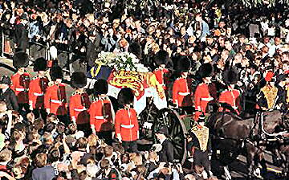
More than one million bouquets were left at her London home, Kensington Palace, while at her family's estate of Althorp the public was asked to stop bringing flowers, as the volume of people and flowers in the surrounding roads was causing a threat to public safety.
The reaction of the Royal Family to the death of Diana caused unprecedented resentment and outcry. The Royal Family's rigid adherence to protocol was intepreted by the public as a lack of compassion: the refusal of Buckingham Palace to fly the Union Flag at half mast provoked angry headlines in newspapers. "Where is our Queen? Where is our Flag?" asked The Sun. The Queen, who returned to London from Balmoral, agreed to a television broadcast to the nation. At the urging of Downing Street, what was to be a recorded piece became a live broadcast, and the script was revised by Alastair Campbell to be more "human".
Mourners cast flowers at the funeral procession for almost the entire length of its journey before and after the service, and vehicles even stopped on the opposite carriageway of the M1 as the cars passed on the route to Althorp. Outside Westminster Abbey crowds cheered the dozens of celebrities who filed inside, including singer Sir Elton John (who performed a re-written version of his song Candle in the Wind). The service was televised live throughout the world, and loudspeakers were placed outside so the crowds could hear the proceedings. Tradition was defied when the guests applauded the speech by Diana's brother, Lord Spencer, who strongly criticised the press and indirectly criticised the Royal Family for their treatment of her, although Lord Spencer himself had years earlier refused Diana permission to use a cottage at Althorp as a sanctuary due to his fears about press intrusion into his family home.
In the midst of this "public outpouring of grief" many commentators and members of the public found themselves nonplussed by what they considered to be mawkish, sentimental and self-indulgent displays of insincere emotion.
The writer Francis Wheen recalls: On that Sunday afternoon I was telephoned by a neighbour, a ferociously conservative columnist on the Daily Mail: “I can’t bear much more of this. Fancy a drink in the pub?” Disgust was also aroused through what was perceived by many as a hypocritical turnaround on the part of many sectors of the media, in particular the tabloid press, who had abruptly shifted from the portrayal of Diana as a promiscuous, manipulative bimbo to the depiction of Diana as a saintly martyr.
When the satirical magazine Private Eye issued a mock editorial consisting of a retraction of previous negative statements made against Diana, the magazine found itself subjected to heavy criticism from the press and was temporarily removed from the shelves of WH Smith and other newsagents. Defenders of the magazine argued that the parody had been directed towards the attitude of the media, and not the death in itself; the episode was seen by many to be indicative of a pervasive self-righteous and bullying mentality.
Diana, Princess of Wales is buried at Althorp in Northamptonshire on an island in the middle of a lake called the Round Oval. A visitors' centre is open during summer months, allowing visitors to see an exhibition about her and walk around the lake.
During the four weeks following her funeral, the overall suicide rate in England and Wales rose by 17%, compared with the average reported for that period in the four previous years. Researchers suggest that this was caused by the "identification" effect, as the greatest increase in suicides was by people most similar to Diana: women aged 25 to 44, whose suicide rate increased by over 45%.
In the years after her death, interest in the life of Diana has remained high, especially in the United States of America. Numerous manufacturers of collectables continue to produce Diana merchandise. Such items have drawn strong derision from certain quarters for their alleged kitsch value. Some even suggested making Diana a saint, stirring much controversy.
As a temporary memorial, the public co-opted the Flamme de Liberté (Flame of Liberty), a monument near the Alma Tunnel, and related to the French donation of the Statue of Liberty to the United States. The messages of condolence have since been removed, and its use as a Diana memorial has discontinued, though visitors visit and still leave messages at the site in her memory. The concrete wall at the edge of the tunnel is still used as an impromptu memorial for people to write their thoughts and feelings about Diana. A permanent memorial, the Diana, Princess of Wales Memorial Fountain was opened in Hyde Park in London on 6 July 2004, but it has been plagued with problems and has been declared off-limits to the public at least twice for repairs.
In 1999, a little more than a year after her death, the journalist Christopher Hitchens made a comment about her while on a cruise ship. He stated that Diana "has in common with a minefield the following: relatively easy to lay but extremely difficult, expensive, and dangerous to get rid of." When there was a backlash concerning his quip he said he thought, "it was funny."
Diana was ranked third in the (2002) Great Britons poll sponsored by the BBC and voted for by the British public. In this poll, she was ranked just above Charles Darwin (4th), who changed the course of history through his theory of natural selection, William Shakespeare (5th), regarded by many as the greatest writer in the English language, and Isaac Newton (6th), widely held to be the most influential scientist in the history of humanity.
In 2003, Marvel Comics announced it was to publish a five-part series entitled Di Another Day (a reference to the James Bond film Die Another Day) featuring a resurrected Diana, Princess of Wales as a mutant with superpowers, as part of Peter Milligan's satirical X-Statix title. Amidst considerable (and predictable) outcry, the idea was quickly dropped. Heliograph Incorporated produced a roleplaying game, Diana: Warrior Princess by Marcus L. Rowland about a fictionalised version of the twentieth century as it might be seen a thousand years from now.
After her death, the actor Kevin Costner, who had been introduced to the Princess by her former sister-in-law, Sarah, Duchess of York claimed he had been in negotiations with the divorced Princess to co-star in a sequel to the thriller film The Bodyguard, which starred Costner and Whitney Houston. Buckingham Palace dismissed Costner's claims as unfounded.
Styles
The Honourable Diana Spencer (1 July 1961–9 June 1975)
The Lady Diana Spencer (9 June 1975–29 July 1981)
Her Royal Highness The Princess of Wales (29 July 1981–28 August 1996)
Diana, Princess of Wales (28 August 1996–31 August 1997)
The style "Princess Diana" was incorrect at all times of her life, though often used by the public and the media. After her divorce she ceased to be the Princess of Wales but was styled Diana, Princess of Wales acting on precedent of divorced peeresses where the former title acts as a surname.
Lineage
Prior to her marriage, much research was done into Diana's lineage by genealogists. It was much publicized that her ancestry included links to individuals such as Hollywood screen legend Humphrey Bogart (who was her 7th cousin), and poet Edmund Spenser, the author of The Faerie Queen.
Actor Oliver Platt is more closely related; both he and Diana, Princess of Wales are descendants of Frances Work, a late 19th-century American heiress who was briefly the wife of the Hon. James Burke Roche, later 3rd Baron Fermoy.

Diana death probe: two computers stolen
Taken from the ‘SA Independent Online’ February 07 2006
London - Two laptops have been stolen from offices used by a former police chief who is heading a probe into the death of Princess Diana in a Paris car crash in 1997, a newspaper said on Tuesday.
The theft sparked fears that the equipment may contain material from Operation Paget, the investigation headed by former Metropolitan Police Commissioner Lord John Stevens, the Daily Express said. However, a spokesperson for the Metropolitan said the computers did not contain any sensitive information or any material linked to the probe.
Lord Stevens, a former chief constable of Northumbria Police, has an office in Gosforth on the outskirts of Newcastle upon Tyne. Detectives with Northumbria Police are investigating two burglaries there in the past 10 days, the newspaper said.
The first took place on the weekend of January 28 to 29 when the computers and cash were taken. The second took place last weekend, when nothing was taken. Northumbria Police also said there was no evidence that the break-ins were linked to Lord Stevens' work.
Stevens has been investigating speculation that the princess of Wales' death was not the result of a straightforward car accident. The probe was ordered in 2004 by the royal coroner, Michael Burgess, amid continuing conspiracy theories.
Diana married Prince Charles, the heir to the throne, in 1981 and the pair separated 11 years later. Diana, 36, her lover Dodi Fayed and their chauffeur Henri Paul were killed when they crashed in a Paris tunnel on August 31, 1997.
A two-year French investigation blamed Paul for losing control of the car because he was high on drink and prescription drugs and driving too fast.
Inquiry into Diana's death shocking - reports
Taken from ‘Stuff Co NZ’ 07 February 2006
The findings of a two-year investigation in the death of Diana, Princess of Wales, will contain some shocking conclusions, British newspapers reported at the weekend. But the inquiry's findings won't become public for some time: Michael Burgess, the Royal Coroner, will receive the report in the next few months and an inquest is not expected until next year.
Lord Stevens, the former Metropolitan Police commissioner heading the investigation, told the Daily Telegraph the inquiry was "far more complex than any of us thought". He said some of the issues raised by Mohammed Fayed, owner of Harrods store, whose son Dodi died with the princess in a car crash in Paris on August 31, 1997, were "right to be raised". Mr Fayed has claimed the couple were victims of an assassination plot orchestrated by Prince Philip and involving British intelligence agencies.
The princess's friends have dismissed suggestions that she was pregnant and the couple were to marry. Lord Stevens said in a recent television interview that his investigation had been "certainly worthwhile'. "It is right to say that some of the issues that have been raised by Mr Fayed have been right to be raised. We are pursing those. It is a far more complex inquiry than any of us thought," he said.
The official conclusion that car driver Henri Paul was drunk and on anti-depressants at the time, and that the car was likely to be the vehicle involved, have never been accepted by the families of Dodi Fayed or Paul.
The Independent on Sunday said Lord Stevens' remarks were a deliberate attempt to prepare public opinion for some shocking conclusions."People are going to be very surprised about what we have to say," said one senior officer closely involved with the inquiry.
Mr Fayed's spokesman refused to comment, saying it was "not appropriate" while the process was ongoing. Another source close to the Harrods boss said Mr Fayed felt "vindicated" by Lord Stevens' comments.

Holingher Mihai Daniel Noris , VII-a , Sc. Alexandru Stefulescu Tg-Jiu

