Europe

The Council of Europe (COE) has developed a series of European symbols for the continent of Europe, and these have since been shared with the European Union (EU). They are intended both as symbols of the organizations themselves, and as a focus for a form of Pan-European identity.

Flag


The flag of Europe is twelve golden stars (pointing upwards) in a circle on a blue background. Although the flag is most commonly associated with the European Union, it was initially used by the Council of Europe in 1955, and is considered to represent Europe as a whole as opposed to any particular organization such as the EU or the COE.
The flag was adopted in 1985 by all EU heads of State and government as the official emblem of the European Union and, since the beginning of 1986, it is used by all European institutions. The Council of Europe — which does not have an organic link with the European Union — owns the intellectual property of the European flag.
The flag has also given Europe its "national colors" of blue and yellow.

Anthem

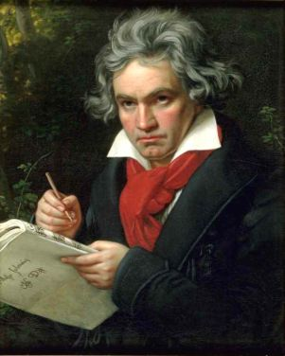
In 1971 the Parliamentary Assembly of the Council of Europe decided to propose adopting the prelude to the Ode To Joy from Beethoven's 9th Symphony as the European anthem. The Council of European Ministers officially announced the European Anthem on January 19th 1972 at Strasbourg: the prelude to "The Ode to Joy", 4th movement of Ludwig van Beethoven's 9th symphony.
The well-known conductor Herbert von Karajan was asked to write three instrumental arrangements - for solo piano, for wind instruments and for symphony orchestra and he conducted the performance used to make the official recording. He wrote his decisions on the score, notably those concerning the tempo. Karajan decided on crotchet = 120 whereas Beethoven had written minim = 80.
The anthem was launched via a major information campaign on Europe Day, 5 May 1972. In 1985, it was adopted by EU heads of State and government as the official anthem of the then European Community - since 1993 the European Union. It is not intended to replace the national anthems of the Member States but rather to celebrate the values they all share and their unity in diversity, it expresses the ideals of a united Europe: freedom, peace, and solidarity.
The European anthem is based on the final movement of Beethoven's 9th Symphony composed in 1823, which contains a modified version of the lyrics of Friedrich Schiller's ode, An die Freude (German for Ode To Joy) written in 1785. This poem expresses Schiller's idealistic vision of the human race becoming brothers - a vision Beethoven shared. It is played on official occasions by both the Council of Europe and the European Union.
Due to the large number of languages used in the European Union, the anthem is purely instrumental and the German lyrics have no official status. For the German lyrics refer to the article about the 9th Symphony. A suggestion for Latin lyrics to the anthem has been written by the Austrian composer Peter Roland, but the lyric has not been accorded official status, and is not used by the EU. This anthem was also sung by the Spanish singer Miguel Ríos, in 1970.

Europe Day

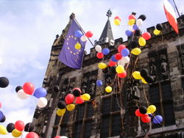
The Council of Europe has celebrated its founding on 5 May 1949 as "Europe Day" since 1964. What is now the European Union adopted 9 May as "Europe Day" at the Milan summit in 1985, to celebrate that Robert Schuman presented his proposal on the creation of an organized Europe, indispensable to the maintenance of peaceful relations, on 9 May 1950. This proposal, known as the Schuman declaration, is considered by many to be the beginning of the creation of what is now the European Union.
9 May is now the more commonly observed date, though some Europeans still prefer 5 May, since the Council of Europe was designed to defend human rights, parliamentary democracy and the rule of law, while the Schuman speech was simply proposing a sharing of French and German coal and steel. Incidentally, May 9 is also celebrated in many former Soviet Union countries as Victory Day, the end of World War II. This is celebrated on May 8 in most Western European countries, but is celebrated on May 5 in the Netherlands and Denmark, and May 7 in Norway.

Motto

An EU motto, In varietate concordia (Latin for united in diversity), was first established through an unofficial process in 2000. It was selected from entries proposed by school pupils submitted to the website www.devise-europe.org, and then accepted by the President of the European Parliament, Nicole Fontaine. The modified version, United in diversity, has been written into the English-language version of the currently stalled Constitution for Europe, and now appears on official EU websites.

