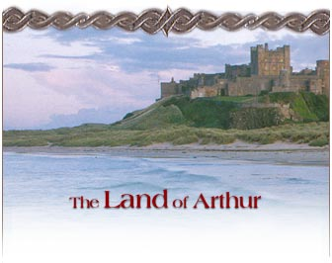

King Arthur is the figure at the heart of the Arthurian legends. He is said to be the son of Uther Pendragon and Igraine of Cornwall. Arthur is a near mythic figure in Celtic stories such as Culhwch and Olwen. In early Latin chronicles he is presented as a military leader, the dux bellorum. In later romance he is presented as a king and emperor.
One of the questions that has occupied those interested in King Arthur is whether or not he is a historical figure. The debate has
raged since the Renaissance when Arthur's historicity was vigorously defended, partly because the Tudor monarchs traced their lineage to Arthur and used that connection as a justification for their reign. Modern scholarship has generally assumed that there was some actual person at the heart of the legends, though not of course a king with a band of knights in shining armor--though O.J. Padel in "The Nature of Arthur" argues that "historical attributes of just the kind that we find attached to Arthur can be associated with a figure who was not historical to start with."
If there is a historical basis to the character, it is clear that he would have gained
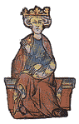
The Enthroned Arthur, from Lancelot du Lac (French, early fourteenth century)
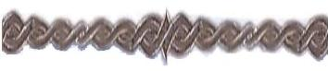

fame as a warrior battling the Germanic invaders of the late fifth and early sixth centuries. Since there is no conclusive evidence for or against Arthur's historicity, the debate will continue. But what can not be denied is the influence of the figure of Arthur on literature, art, music, and society from the Middle Ages to the present. Though there have been numerous historical novels that try to put Arthur into a sixth-century setting, it is the legendary figure of the late Middle Ages who has most captured the imagination.
It is such a figure, the designer of an order of the best knights in the world, that figures in the major versions of the legend from Malory to Tennyson to T. H. White. Central to the myth is the downfall of Arthur's kingdom. It is undermined in the chronicle tradition by the treachery of Mordred. In the romance tradition that treachery is made possible because of the love of Lancelot and Guinevere.

Legendary Arthur

Name.
The name Arthur may be (and according to K. H. Jackson certainly is) a form of Artorius, a Roman gens name, but, according to J. D. Bruce, it is possibly of Celtic origin, coming from artos viros (bear man) - see
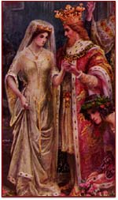
The Marriage of King Arthur and Guinevere.
Welsh arth gwyr (T. R. Davies). Bruce also suggests the possibility of a connection with Irish art (stone).
Life.
An outline of the hero's life is given by Geoffrey of Monmouth (twelfth century) in his Historia Regum Brittaniae - History of the Kings of Britain. Just how much of this life was Geoffrey's invention and how much was

culled from traditional material is uncertain. He tells us that King Arthur was the son of Uther and defeated the barbarians in a dozen battles. Subsequently, he conquered a wide empire and eventually went to war with the Romans. He returned home on learning that his nephew Mordred had raised the standard of rebellion and taken Guinevere, the queen. After landing, his final battle took place.
The saga built up over the centuries and Celtic traditions of Arthur reached the Continent via Brittany. Malory's Le Morte D'Arthur would become what many considered the standard 'history' of Arthur. In this, we are told of Arthur's conception when Uther approached Igraine who was made, by Merlin's sorcery, to resemble her husband. The child was given to Ector to be raised in secret. After Uther's death there was no king ruling all England. Merlin had placed a sword in a stone, saying that whoever drew it out would be king. Arthur did so and Merlin had him crowned. This led to a rebellion be eleven rulers which Arthur put down. He married Guinevere whose father gave him the Round Table as a dowry; it became the place where his knights sat, to avoid quarrels over precedence. A magnificent reign followed, Arthur's court becoming the focus for many heroes. In the war against the Romans, Arthur defeated the Emperor Lucius and became emperor himself. However, his most illustrious knight, Lancelot, became enamoured of Guinevere. The Quest for the Holy Grial began and Lancelot's intrigue with the Queen came to light.
Lancelot fled and Guinevere was sentenced to death. Lancelot rescued her and took her to him realm. This led Arthur to crossing the channel and making war on his former knight. While away from Britain, he left Mordred in charge. Mordred rebelled and Arthur returned to quell him. This led to Arthur's last battle on Salisbury Plain, where he slew Mordred, but was himself gravely wounded. Arthur was then carried off in a barge, saying he was heading for the vale of Avalon. Some said he never died, but would one day return. However, his grave was supposedly discovered at Glastonbury in the reign of Henry II (1154-89).

Charge Given to the Knights by King Arthur
God make you a good man and fail not of beauty. The Round Table was founded in patience, humility, and meekness.Thou art never to do outrageousity, nor murder, and always to flee treason, by no means to be cruel, and always to do ladies, damosels, and gentle women succour. Also, to take no battles in a wrongful quarrel for no law nor for no world's goods.
Thous shouldst be for all ladies and fight for their quarrels, and ever be courteous and never refuse mercy to him that asketh mercy, for a knight that is courteous and kind and gentle has favor in every place. Thou shouldst never hold a lady or gentle woman against her will.
Thou must keep thy word to all and not be feeble of good believeth and faith. Right must be defended against might and distress must be protected. Thou must know good from evil and the vain glory of the world, because great pride and bobauce maketh great sorrow. Should anyone require ye of any quest so that it is not to thy shame, thou shouldst fulfil the desire.
Ever it is a worshipful knights deed to help another worshipful knight when he seeth him a great danger, for ever a worshipful man should loath to see a worshipful man shamed, for it is only he that is of no worship and who faireth with cowardice that shall never show gentelness or no manner of goodness where he seeth a man in any danger, but always a good man will do another man as he would have done to himself.
It should never be said that a small brother has injured or slain another brother. Thou shouldst not fail in these things: charity, abstinence and truth. No knight shall win worship but if he be of worship himself and of good living and that loveth God and dreadeth God then else he geteth no worship here be ever so hardly.
An envious knight shall never win worship for and envious man wants to win worship he shall be dishonoured twice therefore without any, and for this cause

all men of worship hate an envious man and will show him no favour.
Do not, nor slay not, anything that will in any way dishonour the fair name of
Christian knighthood for only by stainless and honourable lives and not by prowess and courage shall the final goal be reached. Therefore be a good knight and so I pray to God so ye may be, and if ye be of prowess and of worthiness then ye shall be a Knight of the Table Round

The Emblem of the Knights

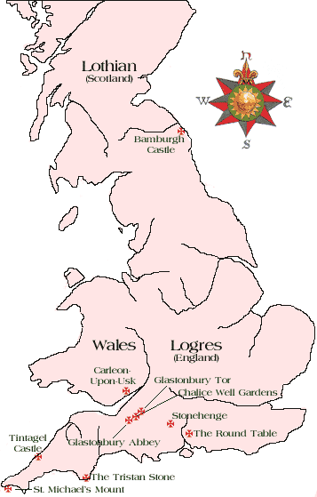
The emblem of the Knights of the Round Table worn round the necks of all the Knights was given to them by King Arthur as part of the ceremony of their being made a knight.
The Order's dominant idea was the love of God, men, and noble deeds.
The cross in the emblem was to remind them that they were to live pure and stainless lives, to stive after perfection and thus attain the Holy Grail. The Red Dragon of King Arthur represented their allegiance to the King. The Round Table was illustrative of the Eternity of God, the equality, unity, and comradeship of the Order, and singleness of purpose of all the Knights.

Land

At the heart of all of the Arthurian legend is the Land itself. To walk through the land is to feel the legends and history itself. Britain has two kinds of geography: the outer, visible one of hills, valleys, trees, rivers, and plants; and the inner, mysterious, myth-haunted one which consists of places that
are often no more than names, like Camelot, Camlan, the supposed site of Arthur's last battle, or Badon, the site of his greatest fight against the Saxons.

Rivers of ink have been spilled by various commentators in their efforts to identify these places, many of which have remained undiscovered for the simple reason that they were never a part of this world at all, but myth and legend. This is not to say that they never existed, only that the physical places ascribed to them are as often as not false.

Alderley Edge
Cheshire, England
According to a local tradition, in the ground below the great outcrop of sandstone, known
as the Edge, there is a cave in which Arthur and his knights lie sleeping. The story goes that a farmer was on his way to market at the nearby town of Macclesfield when he was stopped by an old man who offered to buy the white horse he was planning to sell. Refusing the low offer, the farmer rode on. Despite much interest, no one bought the horse at the market. On the way back, the same mysterious man appeared and this time the farmer accepted the offer. Leading him to the hillside, the old man laid a hand on some rocks, which opened to reveal iron gates at an entrance into the hill. Within the hill, the astonished farmer saw the great king and his knights, together with their mounts, asleep in a vast
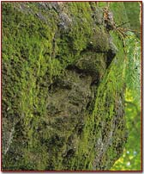
Above Alderley Edge is a bearded, weather-beaten face. Under it is written, Drink of this and take thy fill, for the water falls by the wizard's will.

cavern. The horse was for one of the knights, and the farmer received a bag of gold for it before he fled, hearing the gates clang shut behind him.
Arthur's Seat
Edinburgh, Scotland
This huge crag, which rises to a height of 822 feet above sea-level above the city of Edinburgh,
has been known as Arthur's Seat since the fifteenth century. Part of Holyrood Park, it offers a tremendous view of the surrounding country and of the sea to the east. The 'seat' itself is said to be the notch between the highest point of the peak and a secondary point a little way to the south. In fact, it is probably named after a local hero who happened to bear the name Arthur.
Interestingly enough, Edinburgh is identified with the Castle of Maidens in several Arthurian tales, which is probably because one of its medieval names was Castellum Puellarum (Castle of Women). In the stories it is sometimes a place where a number of female prisoners are kept; at other times it seems to be occupied by seductive women who tempt knights passing by. In at least one version, Arthur's half-sister, the renowned 'enchantress' Morgan le Fay, is its mistress.
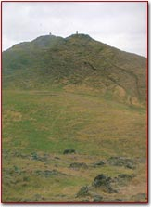
It has been said that the association of the hill with Arthur may be a matter of its being a base for military action in the 6th century.

Cadbury Castle
Somerset, England
Cadbury has been associated with Arthur since at least the sixteenth century, when the distinguished antiquarian John Leland described it in his
account of ancient British history. He wrote: 'At the very south end of the church of South-Cadbyri standeth Camallate, sometime a famous town or castle... The people can tell nothing there but that they have heard say Arthur much resorted to Camalat... ' Camallate or Camalat is, of course, Camelot, the famed citadel of Arthur where the Round Table was housed and from where the Fellowship of Knights rode forth in search of adventure and wrongs to right.
Whether the association of Cadbury is a genuine one has been hotly disputed for a number of years. There are those who think that Leland invented the connection from the close-lying place-names of Queen Camel and West Camel; others would have us believe the identification a true one. Certainly, the archaeological investigation which took place there in the 1960's indicated that the hill, which is really an Iron-Age camp, was re-fortified with extensive earth and timber defences during the crucial period of the sixth century when Arthur is believed to have flourished. The foundations of an extensive timbered hall, and what appears to be the beginnings of an unfurnished church, add further to the speculation, as does the closeness of the site to Glastonbury Tor. A causeway, known as King Arthur's Hunting Track, links the two sites, and a plethora of local
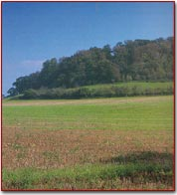
Trees now cloak the sides of Cadbury Camp, yet its imposing bank-and-ditch ramparts would have been a formidable obstacle.

legends support the Arthurian connection. As late as the nineteenth century, when a group of Victorian 'archaeologists' came to investigate the stories
clustering about the hill, a local man asked if they had 'come to dig up the king'. Folklore still retains a memory of Arthur and his knights sleeping under the hill. It is said that if one leaves a silver coin with one's horse on Midsummer's Eve, the horse will be found to be re-shod in the morning.

Cader Idris
Gwyndd, Wales
In the midst of the Welsh countryside sits a mountain almost 3,000
feet in height. The locals claim that the mountain is haunted, and that anyone who spends the night on top of Cader Idris will wake up either a madman or a poet. Different legends surround the large 'hill', and one of the earliest claims that the giant Idris lived there. Three large stones rest at the foot of the mountain, and legend says that Idris got angry once and kicked them, sending them down the mountain.
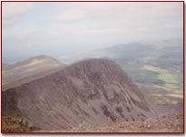
The rock of Cader Idris looms large over the surrounding landscape.
Other Welsh legend states, however, that Arthur made his kingdom there, hence the name Cader Idris: or the Seat of Arthur. No one really knows exactly how Cader Idris fits into all the legends, but the mystical presence cannot be denied when standing on top the mountain, breathing the mist and watching the fog roll out from the giant peak

Dozemary Pool
Cornwall, England
Here, according to local tradition, Sir Bedivere finally threw away Arthur's famous magic sword,
Excalibur. It took him three attempts, so drawn was he to the mighty weapon; when he finally complied with the wounded king's wish, a hand rose from the lake and caught the sword and brandished it three times before vanishing again beneath the water.
In fact, this is one of several sites where this event is supposed to have taken place: Pomparles Bridge, at Glastonbury, is another, as is Looe Pool and Llyn Llydaw in Wales. In reality, despite its atmospheric setting high on Bodmin Moor, Dozemary is one of the least likely sites for the last resting place of Excalibur. For one thing, it is too far from any of the traditional sites of the Battle of Camlan, where Arthur received his fatal wound; for another, despite stories of the lake being bottomless, it is far from that and in fact dried up almost entirely in 1859, making it an unlikely home for the Lady of the Lake.

Local legend describes this as the lake into which Sir Bedivere cast Arthur's magical sword, Excalibur.

Llyn Barfog
Gwynedd, Wales
Llyn Barfog, or the Bearded Lake, is the setting for one of the most colorful of local stories about
Arthur. It is said that a terrible monster, the avanc, lived in the lake, from where it would raid the surrounding countryside. When Arthur came to hear of this, he went to the lake and threw a great chain around the avanc. Then, with the help of his mighty horse (sometimes called Llamrai), he hauled the creature from the lake and killed it. Proof of this is found a short distance from Llyn Barfog in the shape of a stone known as Carn March Arthur, the Stone of Arthur's Horse. Here there is an undoubted hoof-print etched deeply into the rock - supposedly made by Arthur's steed as it
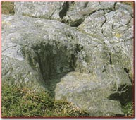
Carn March Arthur, the Stone of Arthur's Horse.
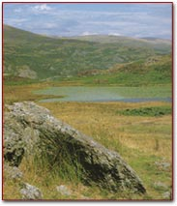
Llyn Barfog, or the Bearded Lake.
strained to pull the avanc from the lake. No one knows exactly what the avanc looked like; it has been variously described as a dragon, a crocodile, and a beaver. Judging from the size of the lake now, the latter would be its most likely inhabitant; no doubt, though, the lake was once much bigger.

Llyn Dinas
Gwynedd, North Wales
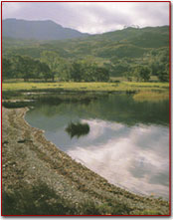
One of the many mysterious pools or lakes which have been associated with Arthur and his heroes.
This still pool of water reflects the shape of nearby Dinas Emrys and it is said to have been the site of a long-ago battle between Owein, one of Arthur's greatest warriors, and a giant. Here, also, in a secret place, the usurper-king Vortigern is supposed to have hidden the throne of Britain beneath a great stone. This may be in part a memory of Merlin's treasure, which is apparently buried beneath the nearby hill.

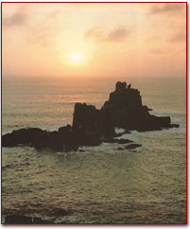
Like many other stories of drowned lands, one cannot help wondering if Lyonesse really lies here, lost forever beneath the restless tides on these windswept cliffs.
Lyonesse
Cornwall, England
To stand on the tip of Land's End and look out towards the Isles of Scilly is to view the remains of a once thriving kingdom. It was name Lyonesse and tradition
records that it was ruled over by Tristan's father. After his death, Tristan became heir to this rich land, but he was never to take up his inheritance, because Lyonesse sank beneath the sea while he was still at his Uncle Mark's court in Cornwall. Numerous legends surround this wild promontory, including one which describes a local man, named
Trevilian, who foresaw the disaster, and leaping on his white horse, outran the advancing sea and took refuge in a cave near Marazion. From there, he watched Lyonesse disappear. The family coat of arms still bears a horsLyonesse has been variously identified with Lothian in Scotland - which was written in old French as Loonois - and with Leonais in Brittany, whereas in Cornwall it is called Lethowstow. It is one of several drowned lands - another being the Cantref Gwaelod which once lay where Cardigan Bay now stretches. The sixteenth-century antiquarian, William Camden, collected a number of stories from the local people, and recalls that they referred to the Seven Stones reef off Land's End as the City of Lions (Lyonesse). They also claimed to be able to hear the bells of the drowned city ringing out during rough seas, a story which is still current today. Certainly, if one takes a boat out on a calm day it is possible to catch a glimpse of walls beneath the water, and what are clearly the remains of field boundaries show up at low tide along the sands of the Sampson Flats between the isles of Tresco and Sampson. e emerging from water.

Merlin's Cave
Tintagel - Cornwall, England
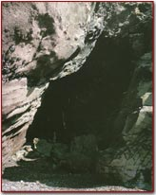
The rocks of Tintagel cliffs loom out over the entrance to Merlin's Cave, making it a dark and gloomy place.
Tennyson made this place famous in his Idylls of the King when he described waves bringing the infant Arthur to the shore, where he was plucked out by Merlin and carried to safety. Local legend has long associated this cave - which fills with water at every high tide - with the great enchanter. It is certainly a place of considerable atmosphere, where one might indeed expect to see Merlin approaching, with his staff held up to illuminate the darkness of the cave. It is now mostly the haunt of scuba-divers in search of shells and fossils.
Roche Rock
Cornwall, England
The story of the doomed love of Tristan and Iseult is one of the most famous and much loved subjects of the medieval romancers who created the vast epics of Arthurian literature. Tristan was King Mark's nephew who, having been sent to fetch his uncle's bride-to-be from Ireland,
accidentally shared a love potion with her so that the two fell hopelessly in love. Thereafter, their lives were lived in a series of furtive trysts, while they both sought to escape the traps laid for them by the suspicious Mark. In the end, Tristan met his death and Iseult, unable to live without him, followed soon after.
A number of sites in and around Cornwall and the far north commemorate this tragic tale. One of the most spectacular is Roche Rock, a massive outcrop of granite, rising from a landscape ruined by clay mining, on which is perched the remains of a fifteenth-century chapel. A contemporary theory, first advanced by E. M. R. Ditmas in her study of the topography of the Tristan legend, suggests that this may have been the site of the hermit Ogrin's chapel, where the lovers, having escaped from King Mark, found temporary refuge. The medieval poet Beroul, who wrote one of the earliest versions of the story, appears to display an intimate knowledge of the Cornish landscape, and his description of Ogrin's chapel certainly bears a more than passing resemblance to Roche Rock.
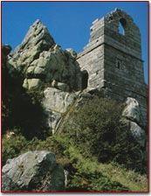
A dangerous winding way over broken rocks leads up to the remains of the tiny chapel.
A later version of the story speaks of Tristan's escape from Mark's soldiers - who had locked him in a cell within another chapel - by jumping from the window down on to some perilous rocks. Such a feat would not be beyond an athletic man, though the result might well be fatal. Near by, at Chapel Point, overlooking
the sea near Mevagissey, is the supposed site of 'Tristan's Leap', but a far more likely site would seem to be Roche Rock, where such a dramatic escape would have stayed in the minds of local story-tellers and might well have become known to one of the authors of the early Tristan story.

St Govan's Chapel
Dyfed, Wales
St Govan's Point is the most southerly point on the Pembrokeshire coast. Nearby is St Govan's Chapel, a tiny cell measuring 18 by 12 feet.
Most of it dates from the thirteenth century, but parts of it - the altar and a seat cut in the rock - may be much earlier, possibly even as early as the sixth century, when the saint reputedly established a hermitage here after miraculously escaping pursuit by pirates. The rock itself, so the story goes, opened and closed around him, keeping him hidden until his pursuers had gone.
Another story connects no lesser person than Sir Gawain - Arthur's nephew, with the site. According to local legend, he is buried here, having retired to live out his days as a hermit after Arthur's death. This conflicts with other stories which place Gawain's death before the final battle in which Arthur met his end. There is a further conflict in that no one can decide whether Govan is a corruption of Gawain - in which case the saint is probably fictitious - or the reverse, so that one would assume that Gawain's name became attached to the place some time after the end of the Arthurian era.
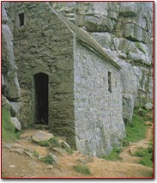
A flight of worn stone steps leads up to the tiny chapel where St Govan (or Gawain) had his cell.

The Structures of Land

Bamburgh Castle
Northumberland, England
Towering above the tiny village of Bamburgh on the bare, sandy coastline of Northumberland, the massive walls of this medieval fortress are one of two such places believed to be the original site of Lancelot's castle of Joyous
Garde. Interestingly, there was a Dark-Age stronghold on the same site, which may account for this tradition.
In 547 it became the capital of the Northumbrian 'Kingdom' of the Angles who had settled there in the early part of the sixth century; as such, it would have been a stronghold of the Saxon alliance, who were Arthur's prime enemies in his fight to maintain British rule. At the time, the site was not called Bamburgh, but seems to have been named 'Din Guayrdi', which may have suggested Joyous Garde to Sir Thomas Malory, who first described it as Lancelot's holding in his fifteenth-century Arthurian 'novel', Le Morte d'Arthur.
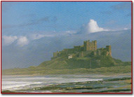
This is the probable site of Sir Lancelot's famous castle of Joyous Garde, where he once gave refuge to Tristan and Iseult, and where he himself retired to escape the rumours of his liaison with Arthur's Queen.

Carleon-Upon-Usk
Gwent, Wales
According to Geoffrey of Monmouth's twelfth-century History of the Kings of Britain, this was Arthur's chief city. In a lengthy description, it is made to rival the later Camelot in its splendour. It contained two minster churches where choirs sang praises to God non-stop, and a college of 200 scholars skilled in the arts of astrology and prediction. This is where Arthur was crowned and held his first court, presiding over a rich company including liveried knights and their ladies.
The present site contains the ruins of a fine Roman amphitheatre and extensive buildings, including bath houses and barracks. Until recent times, the central mound of the amphitheatre was called 'The Round Table'. Geoffrey's account probably lies behind this identification, and it was almost certainly prompted by his own patriotism - Monmouth, where Geoffrey was
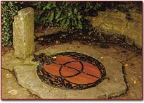
The Well-head is covered by a wooden lid with a fine wrought-iron sculpture.
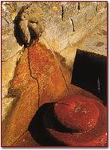
Water spills out of this lion-headed fountain into a shallow bowl.
born, lies only a little way to the north. The town's Roman name, City of Legions (Caer-Leon) led to its identification as the possible site of the ninth of the twelve great battles fought between Arthur and the Saxons.

The Chalice Well Gardens
Glastonbury - Somerset, England
Chalice Hill is the third and gentlest of the three hills which form the heart of Glastonbury's sacred landscape. It stands between the town and the Tor, effectively hiding the bulk of the taller hill from the town. It has long been considered the most sacred of the hills, and it is believed by many to have been the final resting place of the Grail. A spring, rich in iron which turns the water red, rises here, and a peaceful garden has grown up around it in the past decade, owned and looked after by a local trust. Within the garden, which is surrounded by medieval stonework and rises up the lower slopes of the hill, there are a number of sheltered spots in which the visitor may stop and meditate or dream of the Grail and Arthur.
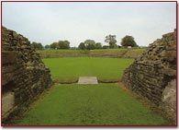
The Round Table was once believed to have stood here.
The well-head is covered with an elaborate lid with a fine wrought-iron sculpture of the Vesica Pisces, a sign interpreted as representing the overlapping of the inner and outer worlds. Lower down, the waters spill out of a carved ornate fountain-head and fill a series of stepped bowls which echo the shape of the well-cover design. The reddish tinge to the water resulted in its once being called the Blood Spring; in modern times, it has been mystically associated with the blood of Christ caught in the Grail.

Glastonbury Abbey
Glastonbury - Somerset, England

Crouched in the lee of three hills, most notably the Tor, the ruins of Glastonbury Abbey are all that remain of what was once the greatest monastic foundation and church in all of Britain, second only in wealth and size to Westminster. At the height of the Middle Ages it was a shrine second to none in Europe, considered by some to be as important as Rome itself.
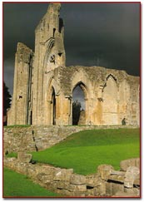
Here, according to legend, once lay the body of King Arthur.
Here, according to legend, came Joseph of
Arimathea, the uncle of Jesus who gave up his tomb to house the body of his nephew. Later, Joseph was given the Holy Grail, the most mystical vessel which had been used to celebrate the Last Supper and the first Eucharist, and which caught some of the blood of the crucified Christ as he hung upon the cross. After the Resurrection, Joseph fled to Britain with the cup and founded the first Christian church on the ancient island of Ynys Witrin, sometimes known as the Glass Isle, or Avalon, better known today as Glastonbury. Arthur's body was brought here to be buried. Today, a plaque marks the spot where, in 1191, his tomb was apparently uncovered by builders working on the restoration of the abbey after it had been almost destroyed by fire in 1184. Whether this was truly Arthur's grave or a complicated forgery perpetrated by the monks to raise funds to rebuild their half-burned church has been contested ever since. A lead cross, last seen by William Camden in the eighteen century, used to be displayed in the abbey. It read: Here lies buried the renowned King Arthur in the Isle of Avalon.
There are those who believe it a forgery and those who think it was the genuine gravestone of Britain's greatest king.

Glastonbury Tor
Glastonbury, Somerset England
Rising like a beacon from the flat Somerset plain, the Tor seems to beckon the pilgrims who journey in their thousands to this remarkable spot, once described as 'this holiest earth'. People come in search of many things: the Grail;enlightenment; inspiration. Many claim to have found their goal, and remain in the peaceful market
town to the bewilderment of the local inhabitants. Beneath the Tor is said to lie a subterranean kingdom ruled over by the Lord of the Wild Hunt, Gwynn ap Nud, a powerful other-worldly figure who was once banished by the Celtic St. Collen, but who is still believed to haunt the hills around Glastonbury. A recent theory claims the existence of a man-made, sevenfold maze, carved out of the Tor itself. This, it is said, was once a sacred processional way, used by priests and priestesses to reach the stone circle which then crowned the Tor. Modern pilgrims still trace its path to the summit and speak of visionary experiences when they have done so.
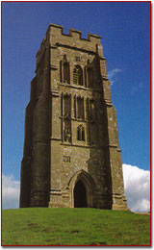
Michael. On top of the Tor stands the tower of the church of St.
From the summit of the Tor, which rises some 500 feet above sea level, there is a panaromic view of the surrounding countryside. Cadbury Castle can be glimpsed away to the south, and Brent Knoll rises away to the west, near the Bristol Channel. The Tor was probably once an island, hence its identification with the mysterious Island of Avalon, a place between the worlds, where tradition says that Arthur came to be healed of his wounds and to await his recall in a time of great need. This is the most likely reason for the legend of his grave being found in the abbey ruins below the hill.
St. Michael's Mount
Penzance - Cornwall, England
Believed to mark the site of a great battle between Arthur and a local giant, this dramatic building rises above the sands of Mount's Bay, where tradition had it that Joseph of Arimethea used to come to ply his trade as a tin merchant.
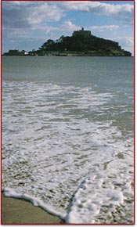
St. Michael's Mount stands out against the ocean... at low tide a person can walk out to the island.
Joseph is later believed to have brought the sacred relic of the Holy Grail to Britain, and to have built the first church at Glastonbury, in Somerset. A firmly entrenched tradition says that he brought his young nephew, Jesus, with him on one of his many trips to Britain. Since biblical testimony is silent about the life of Jesus before His ministry, there could be some truth in this.
According to local legend, the hermit Ogrin, who lived at nearby Roche Rock brought about a brief reconciliation between the estranged King Mark and his would-be Queen Iseult, who had been living in the wilds with Tristan. Because the Queen had only rags to wear, Ogrin bought fresh clothing and a horse for her at a fair on the Mount of St. Michael.

The Round Table
Winchester, Hampshire England
Accounts differ about the origin of the Round Table, at which Arthur's knights met to tell of their deeds and from which they invariably set forth in search of further adventures. The Norman chronicler Wace was the first to mention it, in his Roman de Brut of 1155. There, he simply says that Arthur devised the idea of a round table to prevent quarrels between his barons over the question of precedence. Another writer, Layamon, adapted Wace's account and added to it, describing a quarrel between Arthur's lords which was settled by a Cornish carpenter who, on hearing of the problem, created a portable table which could seat 1600 men. Both Wace and Layamon refer to Breton story-tellers as their source for this and there is little reason to doubt them. This being the case, the origins of the table may well date back to Celtic times, and even be traceable to the age of Arthur himself. In the later medieval stories, however, it is Merlin who is responsible for the creation of the table. Malory, taking up the theme and developing it, made it the centre-piece of his epic re-telling.
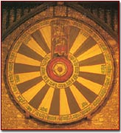
The design displayed on the Winchester Round Table dates from 1552 and was made to impress the visiting Emperor Charles V.
The large wooden table in the Great Hall at Winchester dates from no earlier than the thirteenth century, when it may have been made at the command of King Edward III, who was considering a revival of the Round Table as an order of chivalry. In the end, he dropped the idea and created the Order of Garter instead, but the table remains. Made of oak, it is 18 feet across and nearly 3 inches thick. It weighs nearly 1.25 tons.

Stonehenge
Wiltshire, England
Among the many legends connected with this famous site is one telling of its construction by Merlin. He was asked by Arthur's father, King Uther Pendragon, to construct a fitting memorial for his brother Ambrosius and the War Lords of Britain felled by Saxon treachery in the massacre known as the Night of the Long Knives. Merlin journeyed to Ireland in search of the fabled Giant's Dance, a circle of stones which were believed to possess curative properties if water in which they had been washed was used to bathe the sick.
After a great battle, Merlin conveyed the stones by magic to the shore of the sea, then floated them on rafts across to Britain and set them up on the plain near Salisbury. It has been suggested that this story may contain a distant memory of the method by which the ancient blue-stones, quarried in the Prescelly Mountains far to the north, were brought by sea to the mouth of the River Avon and then taken inland on huge wooden rollers to their present site. Despite numerous theories, which claim Stonehenge to be anything from an ancient observatory to a Druid temple, little is known about the true origin or purpose of this mighty circle of stones.
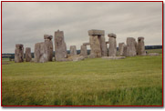
Late Afternoon clouds gather over Stonehenge.

Tintagel Castle
Tintagel - Cornwall, England
Perhaps the most familiar of all the sites associated with Arthur. Local tradition, founded largely on the writings of Geoffrey of Monmouth in his twelfth-century History of the Kings of Britain, claims this is the birthplace of Arthur, from where Merlin took him to be fostered in secret. The dramatic ruins of the castle, dating from the twelfth or thirteenth centuries, are too late to have anything to do with the real Arthur. None the less, they are responsible for a good deal of romantic inspiration. The anonymous medieval writer of The Folie Tristan said that the castle was built by giants and that it used to vanish twice a year - at midwinter and again at midsummer. Thomas Hardy visited and later drew the castle from memory, reinstating its medieval might. Sir Arnold Bax (1883-1953) composed a wonderful tone-poem evoking the majesty and mystery of the place in 1917; to listen to it is to hear the waves crashing against the rocks below the castle.
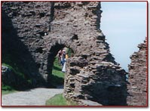
The first gate into Tintagel Castle.
A much earlier monastic site on the island promontory behind the castle dates from a time more or less contemporary with Arthur. More recent discoveries, following excavations in 1994, indicate that it may have been a Celtic site of some importance. The most recent thinking suggests that there may well be something in the legends surrounding the place.

The Tristan Stone
Cornwall, England
Beside the road leading to Fowey in Cornwall stands an ancient, weathered stone measuring some 7 feet in height and set in a concrete base. It was once much closer to Castle Dore and may have been the origin of the association
of this site with the story of the tragic love of Tristan and Iseult. There is a Latin inscription on the stone, now much worn, which can be restored with only a little judicial guesswork to read:
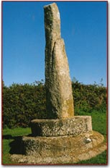
A memorial to the hero Tristan stands beside the road near the Cornish town of Fowey.
Drustans hic iacet Cunomori filius
This means:
Drustanus lies here, the son of Cunomorus
It has been suggested, plausibly, that the characters referred to are Tristan, the nephew of Mark - Drustan being a recognized variant of the hero's name and Cunomorus being a Latinization of Cynvawr. Cynvawr, in turn, is said by the ninth-century author Nennius, who compiled the best historical account of Arthur, to be identified with King Mark.

Other characters of Arthurian legend

Arthur and his knights were not the only characters important to all the legends and prominent in the stories having to do with the Arthurian Era. Many others played important parts in the saga of those times.
In the beginning of the legends there was Merlin, the magician and guardian of young Arthur. He took Arthur from his father, Uther Pendragon when he was just a baby and placed him in the care of Ector, who was later to become a Knight of the Round Table. The Lady of the Lake also was important, giving Arthur his magical sword Excalibur and enchanting Merlin.



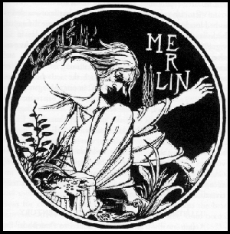
Merlin, or Myrddin, the Magician was, traditionally, the notorious druidic advisor to the great King Arthur. He first appears in extant records (Armes Prydein, Y Gododdin) from the early 10th century as a mere prophet, but his role gradually evolved into that of bard, wise man and wizard. He was apparently given the name Emrys (or Ambrosius) at his birth in Caer-Fyrddin (Carmarthen), only later becoming known as Myddin after this same place. Geoffrey of Monmouth introduced the form "Merlin" as he did not want this character in his History of the Kings of Britain to be associated with the French word, merde, meaning "excrement".Myrddin was the illegitimate son of a monastic Royal Princess of Dyfed. The lady's father, however, King Meurig ap Maredydd ap Rhain, is not found in the traditional pedigrees of this kingdom and was probably a sub-King of the region bordering on Ceredigion. Myrddin's father, it is said, was an angel who had visited left her with child. Merddyn's enemies claimed his father was really a demon, but the original story was presumably invented to save his mother from the scandal which would have occurred had her liaison with one Morfyn Frych (the Freckled), a minor Prince of the House of Coel,
been made public knowledge. Myrddin first came to the attention of the High-Kings of Britain when he was only a boy. The infamous Vortigern had fled from his enemies to Snowdonia, but was having little success in building himself a mountain fortress. The construction works collapsed every night, until Myrddin, "a child without a father," was brought from Caer-Fyrddin to explain that there were two dragons fighting beneath the mountain! In later years, Myrddin appears to have inherited his grandfather's little kingdom, but abandoned his lands in favour of the more mysterious life for which he has become so well known. His knowledge of science, which seemed magical to the people of the time, brought him to the attention of the High-King, Emrys Wledig (Ambrosius Aurelianus). Myrddin helped Emrys erect a memorial stone circle to the massacred British of Vortigern's reign known as the "Giant's Dance" (some think this was Stonehenge or Avebury). Later, he apparently managed to turn the King Uthur Pendragon into the likeness of Gorles of Tintagel so that he could visit the bed of the latter's wife without being discovered. Myrddin's time at King Arthur's court is legendary. He started out as the young boy's tutor, while he grew up with his foster-father, Cynyr Ceinfarfog (the Fair Bearded). When Arthur became King by extracting the sword in the stone, Myrddin acquired the Round Table for the King and helped him set up its great knightly order. When he met the mystic Lady of the Lake at the Fountain of Barenton (Brittany), he persuaded her to present the King with his magical sword, Excalibur. He later fell so deeply in love with the Lady that he agreed to teach her all his mystical powers, and the two became lovers.

The Lady of the Lake
This mysterious female gave Arthur his sword, Excalibur. She stole Lancelot when he was a child and cured him when he went mad. She may be a Celtic lake
divinity in origin, perhaps of the same kind as the Gwagged Annwn - lake fairies in modern Welsh folklore. In Ulrich, the fairy who raised Lancelot is the mother of Mabuz.
As Mabuz is probably identical with the Celtic god Mabon, it would seem that the fairy must be Morgan Le Fay who was, earlier, Mabon's mother. Matrona. A lady of the lake, perhaps a different one, was killed by Balin.
Vivien may very well have been the Lady of the Lake in the Arthurian Legends and stories. Vivien, sometimes called Nineve, Nimue, Niniane, etc., is best known as the woman who sealed Merlin in a cave or a tree. Despite foreseeing his fate, Merlin was unable to prevent being captivated and captured by the woman Richard Wilbur has called "a creature to bewitch a sorcerer." Vivien is an ambiguous character. In Malory, for example, even though Nyneve, who is one of the Ladies of the Lake, deprives Arthur of Merlin's service, she rescues him twice, first by saving him from Accolon who has been given Excalibur by Morgan le Fay to use against Arthur, and then by preventing him from donning the destructive cloak sent to him by Morgan. She also uses her enchantments to punish Ettarde for her mistreatment of Pelleas. In the end she and Pelleas "lovede togedyrs duryng their lyfe."
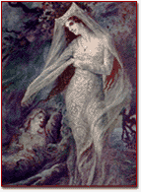
Vivien, the probable Lady of the Lake enchanted Merlin and imprisoned him forever.
The character is ambiguous even in her earliest appearances. In the French Vulgate Estoire de Merlin, she loves the enchanter and seals him in a beautiful
tower, magically constructed, so that she can keep him always for herself. She visits him regularly and grants her love to him. In the continuation to the Vulgate Merlin, known as the Suite du Merlin, the relationship is very different. When
Merlin shows her a tomb of two lovers, magically sealed, she enchants him and has him cast into the tomb on top of the two lovers, whereupon she reseals the tomb and Merlin dies a slow death. Tennyson turns Vivien into the epitome of evil. Though borrowing much from Tennyson, Edwin Arlington Robinson, in the poem, Merlin, makes Merlin's "captivity" voluntary, and his Vivian is less of an enchantress than an interesting woman whom Merlin truly loves.
Queen Guinevere
Variously portrayed in literature, she is called the daughter of King Leodegrance (Lleudd-Ogrfan) of Cameliard by Malory, the daughter of King Ogrfan Gawr (the Giant) of Castell y Cnwclas (Knucklas Castle) by Welsh Tradition, the daughter of King Garlin of Galore by Germanic tradition, the daughter of a Roman noble by Geoffrey of Monmouth and wife of King Arthur by everyone.
In all cases, she is surpassingly beautiful and desirable. She is either forced into or conceives and engineers an extra-marital relationship with Lancelot and is condemned, according to law. She either was a willing accomplice to Mordred's treachery against Arthur, as suggested in Wace and Layamon, or was forced into it against her will as stated in John Hardyng's "Chronicle" (1457). Early mentions of Guinevere, in the Triads of the Island of Britain, give tantalising glimpses of her original relationship with Mordred: he is shown forcing his way into Arthur's Court, dragging the Queen from her throne and striking her, but the reasons why are unknown. The incident may have been related to quarrels between Guinevere and her sister, Mordred's wife, Gwenhwyfach, which are said to have been the eventual cause of the Battle of Camlan.
Giraldus Cambrensis says the cross claimed Guinevere as Arthur's "second wife". This appears to echo the story of the False Guinevere of French Romance: an identical half-sister of the Queen fathered on the same night who persuaded Arthur that she was his true wife. For two and a half years, the King was separated from the real Guinevere until the deception was uncovered. There is also an ancient Triad of the Island of Britain which records Arthur's "Three Chief Queens": Gwenhwyfar daughter of Cywryd, Gwenhwyfar daughter of Gwythyr ap
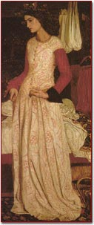
Queen Guinevere

Greidiol and Gwenhwyfar daughter of Ogrfan Gawr. This may further indicate the confusion over the lady's parentage as already alluded to. Alternatively, the three Guineveres could show a common Triple-Goddess motif at the root of many later Celtic characters. Whatever Guinevere was or was not, she has been a useful tool in the hands of the romancers throughout the centuries and has greatly enhanced the legends of King Arthur.

King Mark of Cornwall
King Mark of Cornwall was the brother of Tristan's mother (named Elyzabeth in Malory; Blanscheflur in Gottfried;
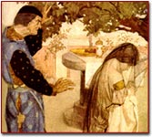
King Mark listens to the crying of Iseult after Tristan's death.
Blauncheflour in Sir Tristrem) and uncle to Sir Tristan. Mark appears in early Celtic literature such as he Triad telling the story of Tristan as one of the three powerful swineherds of Britain. In this Triad, "Drystan son of Tallwch" watches over the swine of "March" (Mark) while the swineherd delivers a message from Drystan to Essylt. The Welsh work was the source for an episode in Masefield's play Tristan and Isolt, in which Arthur appears as a "Captain of the Host" and is subordinate to Mark. There is some evidence for an actual Welsh nobleman, March son of Meirchyawn, behind the figure of Mark.
In the ninth-century Life of Paul Aurelian (St. Pol a monk of Landevennec and patron saint of Paul in Cornwall) by Wrmonoc, Mark is identified with Cunomorus (Welsh Kynvawr), who ruled Cornwall in the early sixth century, and who probably had his seat at Castle Dore, a hillfort near Fowey. Wrmonoc says of St. Paul: "fama ejus regis Marci pervolat ad aures quem alio nomine Quonomorium vocant". Cunomorus and Tristan are associated on the famous Tristan Stone (also located in Fowey), a memorial stone commemorating Drustanus, son of Cunomorus.
Mark figures in the medieval Tristan and Iseult tales as the rival to Tristan, originally as a basically noble man caught up in the tragic circumstances, but
increasingly as a figure who exhibits traits inconsistent with chivalrous conduct. He, or a modern analogue of his character, also appears in modern reworkings of the legend, including those by Thomas Hardy, John Masefield, Martha Kinross, Don Marquis, Edwin Arlington Robinson, Sir Arthur Quiller-Couch, John Erskine, John Updike, and many others.

Constantine
Constantine probably succeeded his father, Cado, as King of Dumnonia in the early 6th century. Literary tradition indicates AD 537, after the Battle of Camlann from which, some sources say, he was the only survivor. He was also, apparently left the High-Kingship of Britain, at this time, by his cousin, King Arthur. Despite such positions of honour, Constantine was described as the "unclean whelp of the lioness of Dumnonia" by his contemporary, St. Gildas. He was rebuked for disguising himself as a Bishop in order to sacrilegiously murder his two nephews in the sanctity of a church. According to Geoffrey of Monmouth, these were, in fact, the treacherous sons of the evil usurper, Mordred, who were killed in Winchester & London. There were many noble Constantines abroad around this period and it is difficult to separate one from another. However, it appears that, as an old man, this King's character was greatly changed through grief brought about by the death of his loving wife. One day, while out hunting a deer, his prey took shelter in St. Petroc's cell. So impressed was the King by the saint's power that he and his body guard immediately converted to Christianity. Constantine gave Petroc an ivory hunting horn in commemoration of the event and this was long reverred along with the Saint's other relics at Bodmin.
The King became co-founder of this famous Cornish monastery and, soon afterward, abdicated the throne in favour of his son, Bledric, in order to take up the religious life himself. He moved amongst his people, founding churches at the two Constantines, near Padstow and Falmouth, and at Illogan; also at Milton Abbot and Dunsford in Devon.

Sir Ector

Sir Ector was a nobleman who was entrusted with Arthur by Merlin when Arthur was still a baby. Arthur grew up knowing Ector as his father, and Ector remained clueless as to the true identity of the young Arthur. Sir Kay was also the son of Ector, and Kay and Arthur grew up together as stepbrothers.
Ector is the Welsh form of the name Hector. Sir Ector lived in Caer Gal, above the River Dee, west of Bala.
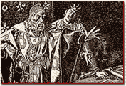
Sir Ector conversing with his son, Sir Kay.

The Fisher King
The Fisher King
was a king encountered during the Quest for the Holy Grail. He is sometimes, but not always, identified with the Maimed King. He is called Pelles in the Vulgate Version, in which the Maimed King is named Parlan or Pellam. In Manessier's Constitution we are told he was wounded by fragments of a sword which had killed his brother, Goon Desert. By Chretien we are told he could not ride as a result of his infirmity, so he took to fishing as a pastime. Robert de Boron gives his name as Bron and tells us he earned his title by providing fish for Joseph of Arimathea. In Sone de Nausay he is identified with Joseph of Arimathea himself. By Wolfram he is called Anfortas.
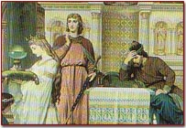
Sir Percivale failed to ask three vital questions about the Fisher King causing the King unnecessary pain.

The Green Knight
The Green Knight was a character featured in the classic poem Sir Gawain and the Green Knight (fourteenth century) and its derivative The Green Knight (c. 1500). This knight came into Arthur's hall and asked any one of his knights to trade blows.
Gawain accepted this challenge and he was allowed to strike first. He cut off the Green Knight's head. The latter calmly picked it up and told Gawain to meet him on New Year's Morning for his turn.
On his way to this meeting, Gawain lodged with a lord and each agreed to give the other what he had obtained during each day of Gawain's stay. On the first day, when the lord was out hunting, Gawain received a kiss from his wife which was duly passed on. On the second day, he received a brace of kisses which were also passed on. On the third day he was given three kisses and some green lace which would magically protect him, but only the three kisses were passed on. Having left the lord's residence, Gawain arrived at the Green Chapel where he was to meet the Green Knight. He knelt for the blow. The Green Knight aimed three blows at Gawain, but the first two did not make contact and the third but lightly cut his neck.
The Green Knight turned out to be the lord with whom he had been staying and he said he would not have cut Gawain at all had the latter told him about the lace. The Green Knight was called Bertilak and he lived at Castle Hutton. The tale bears a striking resemblance to an Irish narrative in which Cu Roi takes the part of the Green Knight and Cuchullain that of Gawain. The Green Knight may have been the Green Man, a wild man featured on inn signboards whose effigy was carried in civic processions.
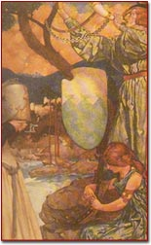
The Green Knight prepares to fight.
Gwion
The son of Gwreang who was left by Ceridwen to stir her cauldron. Drops from it landed on his finger which he sucked and at once understood everything that had happened or was to happen. He fled to avoid Ceridwen, both pursuer and pursued changing into different shapes. Gwion eventually changed himself into a grain of wheat and she changed herself into a hen and swallowed him. She became pregnant with him and bore him as Taliesin. All this may represent an initiatory process, as C. Matthews suggests. A certain similarity may be noted between Gwion and the Irish hero Finn (Fionn) mac Cool, who sucked his thumb when some of the essence of the Salmon of Knowledge was on it. The chewing of the thumb may recall a pagan practice of divination. R. Graves considers that Gwion was a historical person who discovered poetic mysteries and began to compose poetry, using the name of the legendary Taliesin.

Igraine
Igraine comes from the Welsh name Eigyr. She was the mother of Arthur and the daughter of Amlawdd. She married Gorlois, by whom she had a number of daughters. (This husband is sometimes called Hoel.) Uther Pendragon had a relationship with her while he was under a spell which made him resemble her husband. That night Igraine conceived Arthur. Later, after the battle when Gorlois was dead, Uther married Igraine. She never did see Arthur after he was first born, however, as he was given by Merlin to Sir Ector to raise as his son.
There was another Igraine in the Vulgate Merlin who was the sister of Arthur.

Iseult
Iseult was the daughter of King Anguish of Ireland who was the intended bride of King Mark of Cornwall, but as a result of drinking a love-potion, hopelessly enamoured of Tristan. When she heard of Tristan's death,
she died of a broken heart. Her name is not Irish, but derived from Ancient British Adsiltia (she who is gazed on). Attempts to associate her with Chapelizod, Dublin, are due to a false derivation of that place name.
Tristan and Iseult are second only to Lancelot and Guinevere as the great lovers of the Arthurian legends. The story of their tragic love has been the subject of numerous medieval and modern retellings. The medieval versions of the story are sometimes divided into two branches, called the courtly and the common versions. The former is represented by the Tristan of the Anglo-Norman poet Thomas, which was written in the latter part of the twelfth century. His version in turn influenced Gottfried von Strassburg, whose Tristan, written in the first decade of the thirteenth century, is one of the great romances of the Middle Ages, and the Old Norse Tristrams saga (1226).
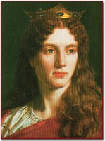
A 19th Century artist conception of Iseult.
Lot Luwddoc, King of Gododdin
Lot Luwddoc (of the Host) is the famous king of legend who married Anna-Morgause, the half-sister of the great King Arthur, and became father of Gawain. The Brut y Brenhinedd - the Welsh translation of Geoffrey of Monmouth's History of the Kings of Britain - confuses him with Llew ap Cynfarch, brother of Urien Rheged, another powerful king in Northern Britain. Lot, however, had a more obscure ancestry descending ultimately from Caradog, the pre-Roman King of the Catuvellauni tribe, who was taken as a captive to Rome in AD 43. In Welsh
tradition, the father of Gawain is called Gwyar, a confused name sometimes, mistakenly, thought to refer to Lot's wife. It seems to have been some kind of heroic title meaning 'Blood'.
Lot ruled Gododdin, in Northern Britain, from his capital at Trapain Law, near Haddington (Lothian), where a post-Roman booty, possibly from his treasury, has been uncovered; but he was also said to have held court at Din Eityn (the Castle Rock in Edinburgh). His kingdom eventually became known as Lothian in his honour. Geoffrey of Monmouth also makes him disputed heir of Norway, presumably through his mother.
In his early years, at least, Lot was a pagan and hagiographic tradition does not portray him in a very positive light. It is said he was so incensed by the shame, brought about by his unmarried daughter's pregnancy, that he had her thrown off a cliff!
Arthurian Romance also treats him poorly. When King Uther fell ill, Lot was entrusted with the command of the British armies in their struggle against the Saxons. Upon Uther's death, however, Arthur was revealed as his heir, and Lot initially rebelled against this new King. He was defeated at the Battle of Bedegraine. Later, having discovered Arthur's affair with his wife, Lot joined a second insurrection in which he was killed by King Pellinore of Listinoire during the Battle of Terrabil. He is traditionally said to have been buried at Dunpender Law in East Lothian.

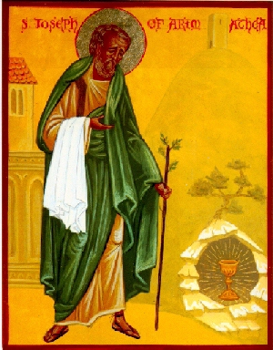
Joseph of Arimathea
Joseph is the wealthy Jew to whose care the body of Christ is given for burial, and who, according to some stories, also comes to possess the cup used by Christ at the Last Supper.
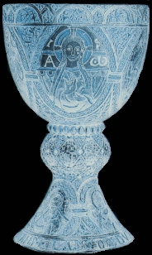
All that is known for certain concerning him is derived from the canonical Gospels. He was born at Arimathea -- hence his surname -- "a city of Judea" (Luke, xxiii, 51), which is very likely identical with Ramatha, the birthplace of the Prophet Samuel, although several scholars prefer to identify it with the town of Ramleh. He was a wealthy Israelite (Matt., xxvii, 57), "a good and a just man" (Luke, xxiii, 50), "who was also himself looking for the kingdom of God" (Mark, xv, 43). He is also called by St. Mark and by St. Luke a bouleutes, literally, "a senator", whereby is meant a member of the Sanhedrin or supreme council of the Jews. He was a disciple of Jesus, probably ever since Christ's first preaching in Judea (John, ii, 23), but he did not declare himself as such "for fear of the Jews" (John, xix, 38). On account of this secret allegiance to Jesus, he did not consent to His condemnation by the Sanhedrin (Luke, xxiii, 51), and was most likely absent from the meeting which sentenced Jesus to death (cf. Mark, xiv, 64).

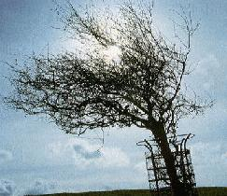
The Crucifixion of the Master quickened Joseph's faith and love, and suggested to him that he should provide for Christ's burial before the Sabbath began. Unmindful therefore of all personal danger, a danger which was indeed considerable under the circumstances, he boldly requested from Pilate the Body of Jesus, and was successful in his request (Mark, xv, 43-45). Once in possession of this sacred treasure, he -- together with Nicodemus, whom his courage had likewise emboldened, and who brought abundant spices -- wrapped up Christ's Body in fine linen and grave bands, laid it in his own tomb, new and yet unused, and hewn out of a rock in a neighbouring garden, and withdrew after rolling a great stone to the opening of the sepulchre (Matt., xxvii, 59, 60; Mark, xv, 46; Luke, xxiii, 53; John, xix, 38-42). Thus was fulfilled Isaiah's prediction that the grave of the Messiah's would be with a rich man (Is., liii, 9). While washing the body, he collects some of the blood in the holy vessel, and from that day forth he is extremely devout, praying daily. His fidelity is unsurpassed, but his zealousness, while spiritually enriching, only evokes the spite and animosity of his peers. So he is forced to leave Jerusalem, accompanied by his sister, his brother-in-law Bron, and a few select followers. Their voyage eventually carries them to Britain, where Joseph sets up the first Christian church at Glastonbury. It is there that the Grail is housed and henceforth used at the celebration of the Mass, or so one version goes. Perhaps a more pertinent telling of the story, though, at least with regard to the Fisher King, is provided by John Matthews in his book, The Grail: Quest for the Eternal. In other versions Joseph goes no further than Europe, and the guardianship of the cup passes to Bron, who
becomes known as the Rich Fisher after he miraculously feeds the company from it with a single fish, echoing Christ's feeding of the five thousand. Legend has it that Joseph visited Glastonbury with the boy Jesus. Joseph was said to have brought the Holy Grail, containing Christ's blood, to Glastonbury after the Crucifixion. His boat sailed up the swampy inlets and landed him at Wearyall Hill. It is said that Joseph struck his staff into the ground where he first landed and the staff took root and blossomed out into a flowering thorn, which still mysteriously blooms twice a year. To the right is the site of the Glastonbury thorn on Wearyall Hill. The thorn tree is botanically known as Craetegus Praecox, which has been said to be a Syrian species. Although the original Glastonbury thorn was cut down by Puritans other specimens exist which flower twice a year in Spring and December. Each Christmas a sprig of blossom is ceremonially cut and sent to the reigning monarch.

A LEGEND OF ANCIENT BRITAIN
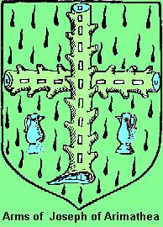
There is a golden Christmas legend and it relates how Joseph of Arimathea -- that good man and just, who laid our Lord in his own sepulchre, was persecuted by Pontius Pilate, and how he fled from Jerusalem carrying with him the Holy Grail hidden beneath a cloth of samite, mystical and white. For many moons he wandered, leaning on his staff cut from a white-thorn bush. He passed over raging seas and dreary wastes, he wandered through trackless forests, climbed rugged mountains, and forded many floods. At last he came to Gaul where the Apostle Philip was preaching the glad tidings to the heathen. And there Joseph abode for a little space. Now, upon a night while Joseph lay asleep in his hut, he was wakened by a radiant light. And as he gazed with wondering eyes he saw an angel standing by his couch, wrapped in a cloud of incense. "Joseph of Arimathea,"
said the angel, "cross thou over into Britain and preach the glad tidings to King Arvigarus. And there, where a Christmas miracle shall come to pass, do thou build the first Christian church in that land."
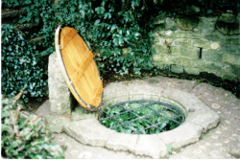
And while Joseph lay perplexed and wondering in his heart what answer he should make, the angel vanished from his sight. Then Joseph left his hut and calling the Apostle Philip, gave him the angel's message. And, when morning dawned, Philip sent him on his way, accompanied by eleven chosen followers. To the water's side they went, and embarking in a little ship, they came unto the coasts of Britain. And they were met there by the heathen who carried them before Arvigarus their king. To him and to his people did Joseph of Arimathea preach the glad tidings; but the king's heart, though moved, was not convinced. Nevertheless, he gave to Joseph and his followers Avalon, the happy isle, the isle of the blessed, and he bade them depart straightway and build there an altar to their God. And a wonderful gift was this same Avalon, sometimes called the Island of Apples, and also known to the people of the land as Ynis-witren, the Isle of Glassy Waters. Beautiful and peaceful was it. Deep it lay in the midst of a green valley, and the balmy breezes fanned its apple orchards, and scattered afar the sweet fragrance of rosy blossoms or ripened fruit. Soft grew the green grass beneath the feet. The smooth waves gently lapped the shore, and water-lilies floated on the surface of the tide; while in the blue sky above sailed the fleecy clouds. And it was on the holy Christmas Eve that Joseph and his companions reached the Isle of Avalon. With them they
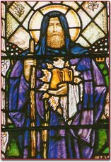
Joseph of Arimathea, from a window in St. John's, Glastonbury.
carried the Holy Grail hidden beneath its cloth of snow-white samite. Heavily they toiled up the steep ascent of the hill called Weary-All. And when they reached the top Joseph thrust his thorn-staff into the ground. And, lo! a miracle! the thorn-staff put forth roots, sprouted and budded, and burst into a mass of white and fragrant flowers! And on the spot where the thorn had bloomed, there Joseph built the first Christian church in Britain. And he made it "wattled all round" of osiers gathered from the water's edge. And in the chapel they placed the Holy Grail. And so, it is said, ever since at Glastonbury Abbey -- the name by which that Avalon is known to-day -- on Christmas Eve the white thorn buds and blooms.

Mordred
in the Annales Cambriae we are told that Arthur and Medrawt (Mordred) perished at Camlan, but we are not told they were on different sides. Geoffrey informs us that Mordred was Arthur's nephew, the son of Arthur's sister
Anna and her husband, Lot of Lothian. The Dream of Rhonabwy makes him Arthur's foster-son as well as his nephew. Geoffrey asserts that, when Arthur was away on his Roman campaign, Mordred seized Guinevere and the throne, thus paving the way for their final battle. Ly Myreur des Historires claims Mordred survived the battle, only to be defeated by Lancelot who executed Guinevere - doubtless because he thought she had willingly complied in being seized - and incarcerated Mordred with her dead body which Mordred ate before dying of starvation. The incest motif in the story of Mordred's birth appears only
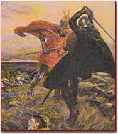
Arthur deals Mordred a mortal blow, but in return Mordred gives Arthur a wound which proved to be fatal.
latterly. The earliest occurence is in the Mort Artu. In Malory's version, Arthur slept with his half-sister Morgause, not knowing they were related and, as a result, Mordred was born. When Arthur discovered the whole truth, in an attempt to kill Mordred he had all children born on the day of Mordred's birth set adrift. The ship carrying Mordred was wrecked, but he survived and was fostered by Nabur.
As an adult, Mordred became one of Arthur's knights and was for a time a companion of Lancelot. He took the part of the Orkney family against the family of Pellinore, slaying Pellinore's son, Lamorak. When Arthur went to fight Lancelot, Mordred was left as regent in his absence. He proclaimed that Arthur was dead and then laid siege to Guinevere, so Arthur's return became necessary.
In Wace, Mordred is not Arthur's son, but Guinevere (whom he seized and made his queen) was his sister. In the Alliterative Morte Arthure, he and Guinevere had a child. In Welsh tradition Mordred married Cywyllog, daughter of Caw, and they had two sons. In the earliest Welsh sources he seems to have been regarded as a hero rather than a villain.

Morgause
Morgause was the half-sister of Arthur who married Lot. She was the mother of Gawain, Gaheris, Agravain, Gareth, and Mordred. According to the Enfaces Gawain, Lot was her page with whom she had an intrigue, as a result of which Gawain was born. In Malory she is Lot's queen who, as the result of an amatory encounter with Arthur (who did not know they were related), gave birth to Mordred. Morgause was slain by her son Gaheris who found her in a relationship with Lamorak, whose father, Pellinore, had slain Lot. Morgause does not seem to have been the original name of this character. In Geoffrey, the wife of Lot is called Anna, sister to Arthur. In De Ortu Waluuanii the part taken by Morgause in
the Enfaces Gauvain is assigned to Anna; and the name Morgause itself seems to be in origin a territorial designation rather than a personal name, for in Diu
Crone Gawain's mother is called Orcades or Morchades, which seems to be taken from the Orkneys (in Latin: Orcades), the name of one of Lot's kingdoms, and Morchades seems to be a variant form of Morgause.

Morgan le Fay
Morgan le Fay is, in Malory's Le Morte d'Arthur, Arthur's half sister, the daughter of Arthur's mother Igraine and her first husband, the Duke of Cornwall. She is also presented as an adversary of Arthur's: she gives Excalibur to her lover
Accolon so he can use it against Arthur (a story retold in Madison J. Cawein's poem Accolon of Gaul) and, when that plot fails, she steals the scabbard of Excalibur which protects Arthur and throws it into a lake.
In Sir Gawain and the Green Knight she is presented as the instigator of the Green Knight's visit to Arthur's court, partly motivated by her desire to frighten Guinevere. Her enmity towards Guinevere has its origin in the Vulgate Lancelot, where Morgan is having an affair with Guiomar, Guinevere's cousin, and Guinevere puts an end to it. Despite the motif of Morgan's enmity towards Arthur and Guinevere, she is also presented as one of the women who takes Arthur in a barge to Avalon to be healed. This view of Morgan as healer has its roots in the earliest accounts of her and perhaps to her origin in Celtic mythology. In the Vita Merlini (c. 1150) Morgan is said to be the first of nine sisters who rule The Fortunate Isle or the Isle of Apples and is presented as a healer as well as a shape-changer. It is to this island that Arthur is brought (though Morgan awaits him and heals him rather than actually fetching him herself). Morgan proclaims that she can heal
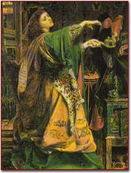
According to legend, Morgan le Fay was able to fly and transform herself into shapes.
Arthur if he stays with her for a long time. Morgan is also said to be the wife of King Uriens and the mother of Yvain or Ywain. Morgan rarely appears in post-medieval works--until the twentieth century when there is a renewed interest in her character. Sometimes she is conflated with Morgause and made to be the mother of Mordred, as is the case in John Boorman's movie Excalibur and a number of modern novels. Fay Sampson has made her the central figure in five novels. One of the most interesting modern portrayals of Morgan appears in Thomas Berger's Arthur Rex where, after a life devoted to evil, she decides to become a nun because of her belief that "corruption were sooner brought amongst humankind by the forces of virtue." Morgan actually does become a defender of good in modern stories like Roger Zelazny's "The Last Defender of Camelot" and Sanders Anne Laubenthal's Excalibur.

Uther Pendragon
King Uther Pendragon was the father of Arthur. He was the brother of Ambrosius whom he succeeded as King of Britain. Falling in love with Igraine, he went to war
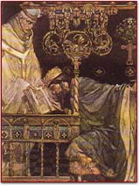
Uther Pendragon vows to deliver the child to Merlin.
with her husband, Gorlois. During the war, Merlin magically made Uther assume the likeness of Gorlois and in this guise he visited Igraine and became the father of Arthur. When Gorlois died, Uther married Igraine. He died in battle and was supposedly buried at Stonehenge.
The Prose Tristan says Uther was once in love with the wife of Argan who defeated him and made him build a castle. The Petit Brut tells how he fought a dragon-serpent in Westmorland (now part of Cumbria). Henry of Huntingdon calls him Arthur's brother while a Cumbrian legend makes him a giant. In Cumbria, he is

said to have founded his kingdom in Mallerstang and to have tried to divert the River Eden to make a moat around his castle.
It has been suggested that Uther is a chimerical character created by a misunderstanding of the Welsh phrase: Arthur mab Uther, which was taken to mean 'Arthur son of Uther' but actually means 'Arthur, terrible son'. However, there is evidence for independent tradition regarding Uther.



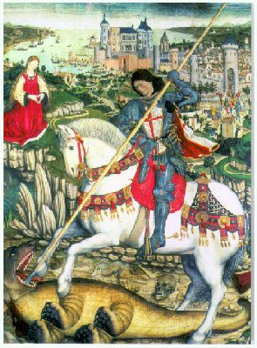

Saint George is England's Patron Saint, a Dragon Slayer and man whose life deeds were deemed to be those which only God himself could have ordained. Saint George was Patron Saint of England in the days of King Arthur and the Knights of the Round Table. His lore of valour against adversity, and protection of the Christians in a determined stand against tyranny and repression sat well with the ideal of the Crusades, Jehad and Holy Wars that would come to pass. The Liberation of the Holy
Lands was a priority to the Realm in the days of the Crusades and England's spin-doctors adopted the icon of Saint George, Dragon Slayer, Liberator of the Oppressed and gave him a National Flag, that is, the Red Cross and a song, Onward Christian Soldiers. In English folklore, Saint George

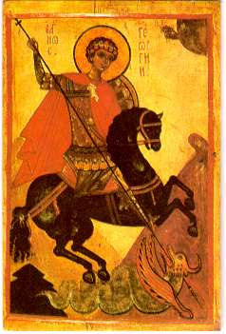
slew the mighty dragon (two places are named:Dragon Hill near Uffington, Oxfordshire, and Lower Stanks, a field outside Hereford) But, in reality, it is thought that St. George came from Cappadocia in Asia Minor, lived at the time of the Roman Emperor, Diocletian, AD 245 to 313 and never actually graced the British Isles. St. George was born in Cappadocia of noble, Christian parents and on the death of his father, accompanied his mother to Palestine, her country of origin, where she had land and George was to run the estate. He was martyred at Lydda in Palestine (Nicomedia). He held an important post in the Roman army - the rank of tribune, or perhaps colonel in modern terms - during the reign of the Emperor Dioclesian (245-313 AD). Dioclesian was a great persecutor of Christians (from about 302) and when the persecutions began George put aside his office and complained personally to the Emperor of the harshness of his decrees and the dreadful purges of Christians. For his trouble, though, he was thrown into prison and tortured. He would not recant his faith however and the following day he was dragged through the streets and beheaded. It is uncertain whether he also tore down the Emperor's decrees as they were posted in Nicomedia. So he was one of the first to perish. The Emperor's wife, Alexandria was so impressed at the Saint's courage that she became a Christian and so too was put to death for her trouble. He was

canonized in AD 494. Pope Gelasius proclaiming him one of those "whose names are justly revered among men but whose acts are known only to God". The legends surrounding Saint George are very varied. One of them concerns the famous dragon, with which he is invariably portrayed. According to legend, a pagan town in Libya was being terrorised by a dragon. The locals kept throwing sheep to it to placate it, and when it still remained unsatisfied, they started sacrificing some of the citizenry. Finally the local princess, Cleolinda, daughter of the King, was to be thrown also to the beast, but Good Saint George came along, slaughtered the dragon and rescued the fair princess. At this the townsfolk converted to Christianity. Some experts think the tale is based on the Greek myth of Perseus rescuing Andromeda from a sea monster. The origin of the legend, which is very well known, came originally from the way in which the Greek Church honoured George. They venerated him as a soldier saint and told many stories of his bravery and protection in battle. The western Christians, joining with the Byzantine ChriSaintians in the Crusades, elaborated and misinterpreted the Greek traditions and devised their own version. The Saintory we know today of Saint George and the dragon dates from the troubadours of the 14th century. The reason for his being adopted as the Saint of Battles was partly because he was a soldier, but also because he is said to have appeared to the Christian army before the Battle of Antioch. It is also said that he appeared to our English King Richard I (the Lionheart) during his Crusade against the Saracens, which served as a great encouragement to the troops. George replaced Edward the Confessor as Patron Saint of England following the Crusades, when returning soldiers brought back with them a renewed cult of St. George. Edward III made St George patron of the Order of the Garter, which seems finally to have confirmed his position. He became the official patron saint of England in 1425 after Henry V's victory at the Battle of Agincourt. In the 15th century his feast day was equated with Christmas. The celebrated Knights of the Garter are actually Kinghts of the Order of Saint George. The shrine built for his relics at Lydda, Palestine was a popular point of pilgrimage for centuries.

