We can still choose how we use our environment. When we use resources wisely, we honour the trust the next generation has placed in us. Environmental threats like global warming and the water crisis take their greatest toll on children. Environmental threats will continue to take their toll, for the mistakes of today will continue to haunt the world tomorrow.
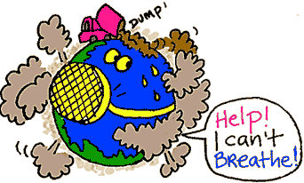
During Earth Day '70, people all over the nation were working on projects to protect our environment. Projects included: organizing neighborhood clean-ups, and planting trees. Demonstrators spoke out on polluters of air, water and noise in an ecology fair. After the first Earth Day, a lot of persons feared that enviromental issues would not become part of the way of life, but much to their surprise, activators continued their fight daily to save our environment .
Over the years, Earth Day has had its successes and struggles. Earth Day struggled because of a lack of political support that year. Supporters held clean up drives, offered educational programs to teach others about saving our earth, and marches were held .
In 1990, on the twentieth anniversary of Earth Day, organized the first International Earth Day. Throughout 140 countries, over 200 million people involved themselves to save our planet.
There are several issues related to Earth Day and our environment that we will discuss throughout this unit. We will be discussing how we can clean up our earth, our air, and our water.
There are billions and billions of people that live on our earth. Each person on earth needs a place to live. We also need materials to build our homes and businesses. There are several things we should do to preserve the land we live on. We can protect our parks, playgrounds and even our own backyards. We can plant flowers and trees to make our world a beautiful place to live. We can learn to reuse and recycle paper, plastics, aluminum, and glass.
Every living thing needs fresh air to breath. There is a lot of air pollution now because of the many factories that make clothing for us and also in the cars we drive. We can cut down on air pollution by walking more, driving in car pools, and riding subways and buses.
Water is essential to life. We use water to drink and to grow plants. Our water is being polluted by sewage, factories waste, and oil. We can better conserve water by not throwing garbage in rivers and lakes. We can also save our water by not wasting water at home.
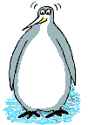
Pollution. You can't miss it, can you? It's everywhere... all over our planet. It makes people, other animals and plants sick or even kills them. It's even making the climate change. Humans are the cause and humans will have to try and stop it... especially you kids, because the future is yours! Please join me in this guide as I find out what's happening and give you ideas to try and make things better for everyone.
Author: Bordiniuc Silvia

