Covent Garden

From Wikipedia, the free encyclopedia
Jump to: navigation, search
Covent Garden
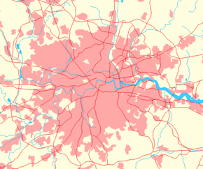
Location
OS grid reference: | TQ303809
Latitude: | 51.5119°
Longitude: | -0.1213°
Administration
London borough: | Westminster, Camden
County level: | Greater London
Region: | London
Constituent country: | England
Sovereign state: | United Kingdom
Other
Ceremonial county: | Greater London
Historic county: | Middlesex
Services
Police force: | Metropolitan Police
Fire brigade: | London Fire Brigade
Ambulance service: | London Ambulance
Post office and telephone
Post town: | LONDON
Postal district: | WC2
Dialling code: | 020
Politics
UK Parliament: | Cities of London and Westminster, Holborn and St. Pancras
London Assembly: | West Central London
European Parliament: | London
London | List of places in London
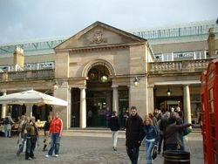
The exterior of Covent Garden market
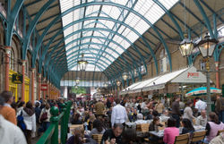
The interior of Covent Garden Market
Covent Garden is a district in central London straddling the easternmost parts of the City of Westminster and the southwest corner of the London Borough of Camden. The area is dominated by shopping and entertainment facilities and contains an entrance to the Royal Opera House Covent Garden, which is also widely known simply as "Covent Garden," and the bustling Seven Dials area.
The area is bounded by High Holborn, Kingsway, The Strand and Charing Cross Road. Covent Garden Piazza is located in the geographical centre of the area and was the site of a flower, fruit and vegetable market from the 1500s until 1974, when the wholesale market relocated to New Covent Garden Market in Nine Elms.

Contents
[hide]
- 1 History
  - 1.1 Roman times to the 1500s
  - 1.2 1600s to 1800s
  - 1.3 Modern day period
- 2 Other information
- 3 External links

[edit] History

[edit] Roman times to the 1500s
A settlement has existed in the area since the Roman times of Londinium.
"Convent Garden" (later corrupted to Covent Garden as we know it today) was the name given, during the reign of King John (1199 - 1256), to a 40 acre (160,000 m²) patch in the county of Middlesex, bordered west and east by what is now St. Martin's Lane and Drury Lane, and north and south by Floral Street and a line drawn from Chandos Place, along Maiden Lane and Exeter Street to the Aldwych.
In this quadrangle the Abbey or Convent of St. Peter, Westminster, maintained a large kitchen garden throughout the Middle Ages to provide its daily food. Over the next three centuries, the monks' old "convent garden" became a major source of fruit and vegetables in London and was managed by a succession of leaseholders by grant from the Abbot of Westminster.
This type of lease eventually led to property disputes throughout the kingdom, which King Henry VIII solved in 1540 by the stroke of a pen when he dissolved the monasteries and appropriated their land.
King Henry VIII granted part of the land to John Russell, Baron Russell, Lord High Admiral, and later Earl of Bedford. In fulfilment of his father's dying wish, King Edward VI bestowed the remainder of the convent garden in 1547 to his maternal uncle, Edward Seymour, Duke of Somerset who began building Somerset House on the south side of The Strand the next year. When Seymour was beheaded for treason in 1552, the land once again came into royal gift, and was awarded four months later to one of those who had contributed to Seymour's downfall. Forty acres (160,000 m²), known as "le Covent Garden" plus "the long acre", were granted by royal patent in perpetuity to the Earl of Bedford.

[edit] 1600s to 1800s
The modern-day Covent Garden has its roots in the early seventeenth century when land ("the Convent's Garden") was redeveloped by Francis Russell, 4th Earl of Bedford. The area was designed by Inigo Jones, the first and greatest of English Renaissance architects. He was inspired by late 15th Century and early 16th century planned market towns known as bastides (themselves modelled on Roman colonial towns by way of nearby monasteries, of which "Convent" Garden was one). The area rapidly became a base for market traders, and following the Great Fire of London of 1666 which destroyed 'rival' markets towards the east of the city, the market became the most important in the country. Exotic items from around the world were carried on boats up the River Thames and sold on from Covent Garden. The first mention of a Punch and Judy show in Britain was recorded by diarist Samuel Pepys, who saw such a show in the square in May 1662. Today Covent Garden is the only part of London licensed for street entertainment. In 1830 a grand building reminiscent of the Roman baths such as those found in Bath was built to provide a more permanent trading centre.

[edit] Modern day period
By the end of the 1960s, traffic congestion in the surrounding area had reached such a level that the use of the square as a market, which required increasingly large lorries for deliveries and distribution, was becoming unsustainable. The whole area was threatened with complete redevelopment. Following a public outcry, in 1973 the Home Secretary, Robert Carr, gave dozens of buildings around the square listed building status, preventing redevelopment. The following year the market finally moved to a new site (called the New Covent Garden Market) about three miles south-west at Nine Elms. The square languished until its central building re-opened as a shopping centre and tourist attraction in 1980. Today the shops largely sell novelty items. More serious shoppers gravitate to Long Acre, which has a range of clothes shops and boutiques, and Neal Street, noted for its large number of shoe shops. London's Transport Museum and the rear entrance to the Royal Opera House are also located on the Piazza.
The marketplace and Royal Opera House were memorably brought together in the opening of George Bernard Shaw's play, Pygmalion, where Professor Higgins is waiting for a cab to take him home from the opera when he comes across Eliza Doolittle selling flowers in the market.
In the mid 1950s, before he directed such films as If and O Lucky Man, Lindsay Anderson directed a short film about the daily activities of the Covent Garden market called Every Day Except Christmas. It shows 12 hours in the life of the market and market people, now long gone from the area, but it also reflects three centuries of tradition in the operation of the daily fruit and vegetable market.
Alfred Hitchcock's 1972 film, Frenzy, likewise takes place amongst the pubs and fruit markets of Covent Garden. The serial sex killer in Frenzy is a local fruit vendor, and the film features several blackly comic moments suggesting a metaphorical correlation between the consumption of food and the act of rape-murder. Hitchcock was the son of a Covent Garden merchant and grew up in the area; and so, the film was partly conceived (and marketed) as a semi-nostalgic return to the neighbourhood of the director's childhood. Supermodel Naomi Campbell was also discovered by a model scout at the age of 15 whilst walking through the streets of Covent Garden.
In a somewhat different musical tradition, Covent Garden's Neal Street was home to the famous punk club The Roxy in 1977.
In 2005 the path leading up to the front of St Paul's Church was given plaques similar to those in Leicester Square which became known as the Avenue of Stars. The plaques quickly deteriorated and only lasted a year before being removed.
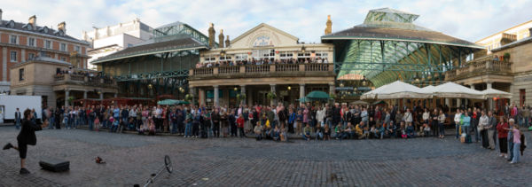
A street performer in front of the Market

Bibliografie : Wikipedia, the free encyclopedia
Mircioaga Dan , cls VIII a B

