WALES

A. INTRODUCTION

Wales, country and principality, part of the United Kingdom of Great Britain and Northern Ireland, united politically, legally, and administratively with England, and occupying a broad peninsula on the western side of the island of Great Britain. Wales also includes the island of Anglesey, which is separated from the mainland by the narrow Menai Strait. Wales is bounded on the north by the Irish Sea; on the east by the English counties of Cheshire, Shropshire, Herefordshire, and Gloucestershire; on the south by the Bristol Channel; and on the west by the St George’s Channel and Cardigan Bay. The maximum north-south length of the Welsh mainland is about 220 km (137 mi); in an east-west direction the width of the country varies between 60 and 155 km (36 and 96 mi). The total area of Wales is 20,760 sq km (8,015 sq mi). Cardiff is the capital, largest city, and principal seaport of Wales.

B. PRINCIPAL CITIES
The chief urban areas of Wales are the cities of Cardiff (population, 2000 estimate, 327,500), the capital, principal seaport, and commercial centre; Swansea (2000 estimate, 230,300), a seaport and industrial centre; Newport (1996 estimate, 136,789), an industrial centre that achieved city status in 2002 as part of Queen Elizabeth II’s jubilee celebrations; Wrexham (1991, 40,614); and Rhondda Cynon Taff (2001, 231,952), the former centre of the Welsh coal-mining industry and now mainly a suburban residential area with some light industry.

- RIVERS AND LAKES
The River Dee, which rises in Lake Bala, the largest natural lake in Wales, and flows through northern Wales into England and then the Irish Sea, is one of the country’s principal rivers. The others are the Wye and the Severn, which both begin near Aberystwyth, flow eastward into England, and then turn south to empty into the Bristol Channel. In the south, many of the rivers flow through steep valleys, including the Usk, Teifi, and Towy. The main river of the north, apart from the Dee, is the Clwyd.

D. LANGUAGE
Both English and Welsh are official languages. English is spoken by most of the population, but according to the 2001 census more than per 30 cent of the population has one or more skill in Welsh. This is defined as either understanding spoken Welsh, speaking Welsh, reading Welsh, or writing in Welsh. This makes a total population figure of nearly 240,000 with at least one skill in the Welsh language. There is much regional variation, however, with over 76 per cent of the population being qualified in the Welsh language in the north-west of the country in Gwynedd and less than 13 per cent in Monmouthshire on the English borders in the south-east. This revival is in part due to the inclusion of Welsh in the school curriculum since 1970 (see Education below), to the establishment of a Welsh language television station in 1982, and to a general resurgence of interest in Welsh culture. Official support for the language after many years of agitation by Welsh nationalists and proponents of the Welsh language has also increased. There are now many more bilingual publications, and most road signs are now in English and Welsh. In 1993 the Welsh Language Act gave parity to English and Welsh in government business and the courts. See Celtic Languages.

E. CULTURE

The Welsh have retained more of the culture of their Celtic forebears than have either the Scots or the English. A strong feeling of national solidarity exists in Wales, and a revival of Welsh nationalism has received political support; representatives of Plaid Cymru (the Welsh Nationalist Party) serve in the House of Commons in London.

The Welsh are best known outside the country for their bardic and choral traditions exemplified in the eisteddfod, and in the male-voice choirs that have their roots in the chapel tradition. The eisteddfod is a celebration of Welsh music, poetry, and culture. Eisteddfodau are held throughout the country each year, culminating in the annual Royal National Eisteddfod, attended by Welsh natives and those of Welsh descent from all over the world. The International Musical Eisteddfod is also held annually in Llangollen, in Denbighshire, north Wales.

F. HISTORY

Before the arrival of the Celts from about 600 bc, Wales was occupied by a number of groups whose presence has been determined archaeologically. From about 4000 bc the Middle Stone Age (Mesolithic) peoples of the area began to be replaced by more advanced Neolithic groups from continental Europe. It was these people who built the stone-chambered tombs called cromlechs found mainly in Anglesey, southern Pembrokeshire and Carmarthenshire, the Gower Peninsula, and the Vale of Glamorgan. During the late Neolithic era and early Bronze Age (about 2400 bc), there was a new wave of migrants from continental Europe, who brought copper technology, improved farming, and a distinctive pottery that has given them their name, the Beaker folk. During the late Bronze Age (1400-600 bc) hill forts were built, of which as many as 600 have been found in Wales.

G. TOURISM

The Welsh coast has been a favourite destination for British holidaymakers since the early 20th century, and its mountains have long attracted walkers and climbers. However, in the past 25 years tourism has developed into one of Wales’ most important economic sectors, employing about 80,000 people. An estimated 780,000 tourist visits were made in 1999. The promotion of tourism in the country is coordinated by the Welsh Tourist Board. Its efforts are helped by the fact that about one quarter of the country has been designated as a National Park or Area of Outstanding Natural Beauty (AONB). As well as Snowdonia National Park, the Brecon Beacons National Park, and the Pembrokeshire Coast National Park, the country has 4 AONBs (the Lleyn Peninsula, Gower Peninsula, Clwydian Range, Anglesey, and the Wye Valley and Shropshire Hills that share countryside with England), 36 country parks, and large stretches of heritage coast. The National Botanic Garden of Wales was opened in May 2000 near Llanarthney, Carmarthenshire.

MIHALCEA LUISA
Clasa a XI-a C
Liceul Teoretic Gh.Ţiţeica

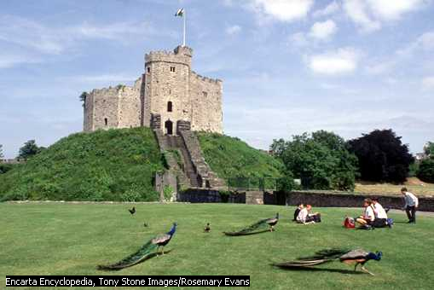

MIHALCEA LUISA
Liceul Teoretic Gh. Ţiţeica
Clasa aXI-a C

