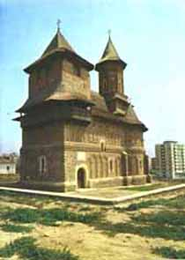
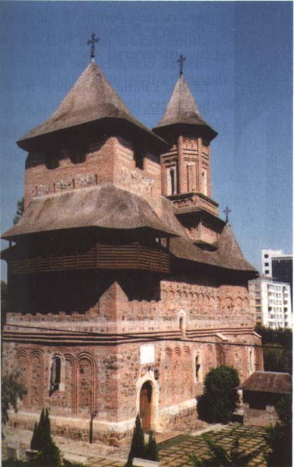
Holy Virgin Church
(17 cent.)

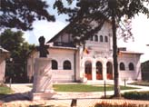
The History Museum

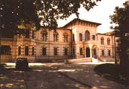
The Art Museum

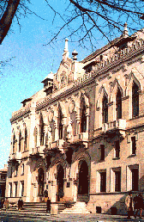

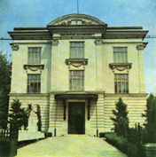
"V. A. Urechia" Library

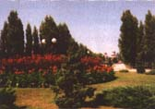
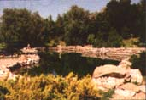
The Botanical Garden

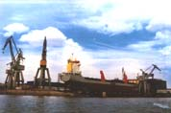
View from The Harbor

"Pescarul" Restaurant

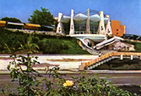

Galati is the 5-th greatest city of Romania. Founded in the Middle Ages, it is a major inland port. Located on the left bank of the Danube at 150 km (80 MMi) from the Black Sea, at the confluence of the Danube with two North - South flowing rivers, Galati developed very early as a main commercial center, the biggest Romanian inland harbor for sea. Galati is about 200 km (120 Mi) North-East of the capital Bucharest, on the border with the former USSR (nowadays Ukraine). The city of Galati is situated not far from the worldwide famous Danube Delta, a unique place in Europe due to its flora and fauna. With over 100 years of history, the shipyard of Galati is the oldest in Romania with a population of 327,975 people estimate in 1997.
Galati is one of the main academic sites of Romania, offering among others unique training in naval architecture and food technology. Galati has also become an important cultural center. Museums, theaters and other cultural sites can be visited at Galati. The Museum of History contains important traces from prehistory, ancient times, middle age as well as from the modern and contemporary epoch together with a valuable ethnographic collection from the county of Galati. The Museum of Romanian Contemporary Art, unique in Romania, was set up in 1956. The collections of the museum contain about 3500 of paintings, sculptures, black and white pictures, works of decorative art, the most valuable being signed by the greatest Romanian artists. The Museum of Natural Sciences includes many elements of the autochthonous flora and fauna, a zoo and botanical garden. A fortress and the "Precista" (Santa Maria) church, together with several treasures lasting from the beginning of the XV-th century testify about the history of Galati. The Museum of Natural Sciences includes many elements of the autochthonous flora and fauna, a zoo and botanical garden.
Of medieval origin, Galati became an international trading center in the 18th century and was a free port from 1834 to 1883. The climate is of continental type, with hot dry summers and windy winters. The town's industry consists mainly of iron-and steel processing and ship building. Galati occupies the first place in the national iron smelting production and is the biggest Romanian centre for metal processing industry. Other industrial branches like: food and textiles are also very well represented in the city and county of Galati. Galati is one of the main academic sites of Romania, offering among others unique training in naval architecture and food technology.
Galati it's a lively and exciting, laden history city to visit with beautiful sights and the oldest shipyard.
Powered by http://www.e-referate.ro/
Adevaratul tau prieten

