Scotland

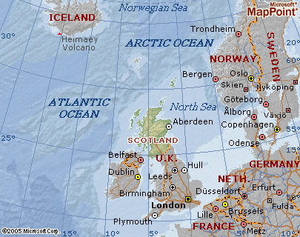
Scotland, one of the four national units that make up the United Kingdom of Great Britain and Northern Ireland. The other units are England, Northern Ireland, and Wales. Edinburgh is the capital of Scotland, and Glasgow is its largest city.
Scotland and its offshore islands comprise the northernmost part of the United Kingdom. The Scottish mainland, which occupies roughly the northern third of the island of Great Britain, is bordered on three sides by seas. To the north and west is the Atlantic Ocean; to the east is the North Sea. Rugged uplands separate Scotland from England to the south. The territory of Scotland includes 186 nearby islands, a majority of which are contained in three groups. These are the Hebrides, also known as the Western Isles, located off the western coast; the Orkney Islands, located off the northeastern coast; and the Shetland Islands, located northeast of the Orkney Islands. The largest of the other islands is the Island of Arran. The total land area of Scotland, including the islands, is 78,790 sq km (30,420 sq mi).
An independent nation for much of its history, Scotland was joined to England by a series of dynastic and political unions in the 17th and 18th centuries. Scotland retains a separate national identity, however, supported by separate legal and educational systems, a national church, a parliament with wide-ranging powers, and other national symbols and institutions.
Scotland has an irregular and deeply indented coastline. The rugged western coast, in particular, is pierced by numerous inlets from the sea. Most of these inlets are narrow submerged valleys with steep sides, known as sea lochs. The larger and broader inlets are called firths. The principal firths are the Firth of Lorne, the Firth of Clyde (see Clyde), and Solway Firth. The major indentations on the eastern coast are Dornoch Firth, Moray Firth, the Firth of Tay, and the Firth of Forth (see Forth). Measured around the various firths and lochs, the coastline of Scotland is about 3,700 km (about 2,300 mi) long.

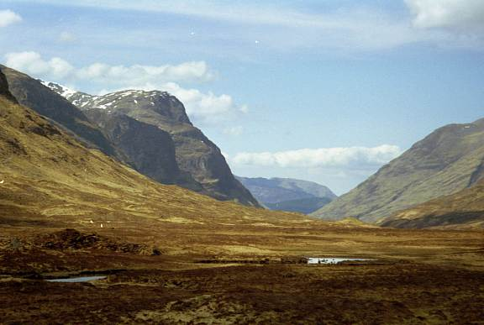
The terrain of Scotland is predominantly mountainous but may be divided into three distinct regions, from north to south: the Highlands, the Central Lowlands, and the Southern Uplands. More than one-half of the land in Scotland is occupied by the Highlands, the most rugged region on the island of Great Britain and the least densely inhabited part of Scotland. The Highlands contain two parallel mountain chains that run roughly northeast to southwest. The rocky summits of the Highlands were carved by ancient glaciers and centuries of rain. Broken by deep ravines and valleys, the region is noted for its scenic grandeur. Precipitous cliffs, moorland plateaus, mountain lakes, sea lochs, swift-flowing streams, and dense thickets are common to the Highlands.
Dividing the parallel mountain ranges of the Highlands is a depression, or fault line, known as the Glen More, or the Great Glen. This depression extends southwest from Moray Firth on the eastern coast to Loch Linnhe on the western coast. Within the Great Glen is a chain of narrow lakes, or lochs, including Loch Ness. These natural lochs are linked by a series of artificial channels and together form the Caledonian Canal. Small craft can use this canal to sail through the Great Glen from coast to coast. To the northwest of the Great Glen lie heavily eroded peaks with fairly uniform elevations ranging from about 600 to 900 m (about 2,000 to 3,000 ft). Between the peaks are numerous valleys, known as glens, carved by glaciers. In the Highlands southeast of the Great Glen the topography is varied and spectacular. This region is traversed by the Grampian Mountains, the principal mountain system of Scotland. The highest peak of the Grampians is Ben Nevis (1,343 m/4,406 ft), the highest summit in the United Kingdom.
To the south of the Highlands lie the Central Lowlands, a low-lying belt of fertile valleys with an average elevation of 150 m (500 ft). Rich soils and most of the country’s coal deposits are found in the Lowlands. This region, which comprises just one-tenth of Scotland’s surface area, is home to Scotland’s leading industries and cities and the majority of the country’s population. Several chains of hills cross the Lowlands, including the Ochil and Sidlaw hills, as do several important rivers, notably the Clyde, Forth, and Tay.
The terrain of the Southern Uplands, a region less elevated and rugged than the Highlands, consists largely of a moorland plateau traversed by rolling valleys and broken by mountainous outcroppings. Only a few summits in the Southern Uplands exceed 760 m (2,500 ft) in elevation, the highest being Merrick (843 m/2,765 ft) in the southwest. The Cheviot Hills adjoin the Southern Uplands region along the boundary with England.
Scotland is endowed with an abundance of streams and lakes. Most lakes are long and narrow. Notable among the lakes, which are especially numerous in the central and northern regions, are Loch Lomond, the longest lake in Scotland; Loch Ness, which according to legend contains a sea monster; Loch Tay; and Loch Katrine.
Many of the rivers of Scotland, especially those in the west, are short, torrential streams, with limited commercial importance. The longest river of Scotland is the Tay. The Clyde, which flows through the city of Glasgow and through the industrial heartland, is Scotland’s most important river and serves as a transportation outlet to the Atlantic Ocean. Other important rivers in Scotland flow east and drain into the North Sea. They include the Forth, Tweed, Dee, and Esk
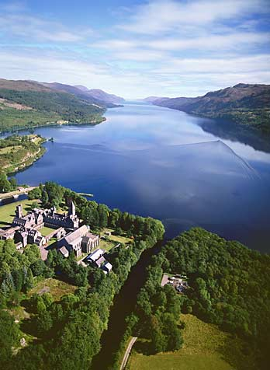
Ness, Loch, long, narrow lake, northern Scotland, forming part of the Caledonian Canal. It extends in a northeastern direction for 37 km (23 mi) from Fort Augustus to a point near the city of Inverness. The average width of the lake is about 2 km (about 1 mi), and the greatest depth is about 230 m (about 754 ft). It is drained by the Ness River into Moray Firth. The lake is reportedly the home of the so-called Loch Ness monster, but its existence has never been proven.

Powered by http://www.referat.ro/
cel mai complet site cu referate

