McDonald's Corporation

McDonald's Corporation, fast-food restaurant company based in Oak Brook, Illinois. Since the 1950s, McDonald’s family-oriented restaurants have revolutionized the fast-food business and the company has become one of the best known in the world. Thousands of McDonald’s restaurants in countries around the world serve millions of customers a day. McDonald’s restaurants, which offer toy promotions and often feature playgrounds, are especially popular with children.
In 1948 brothers Dick and Mac McDonald remodeled their McDonald’s drive-in restaurant in San Bernardino, California, creating the prototype for the modern fast-food restaurant.
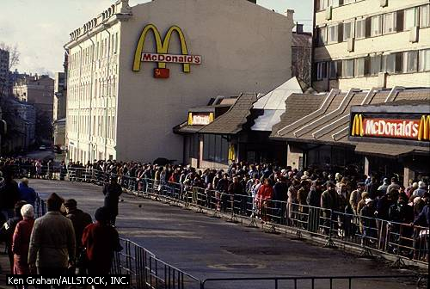
The menu was limited to nine items: hamburgers, cheeseburgers, three types of soft drinks, milk, coffee, potato chips, and pies. French fries and milkshakes were soon added. By focusing on efficient production and service, McDonald’s cut the price of their hamburgers from 30 cents to 15 cents.
By the mid-1950s the original McDonald’s generated $350,000 a year in revenues. In 1954 Ray Kroc, then a 52-year-old salesman of milkshake machines, visited the restaurant and became convinced that its concept could work in other cities. The McDonald brothers agreed to let Kroc sell McDonald’s franchises (the right to market the company’s products within a certain area). In 1955 Kroc established a franchising company known as McDonald’s Systems, Inc. and opened a second McDonald’s restaurant in Des Plaines, Illinois. Within its first four years, the company had opened 228 restaurants, which generated $37.6 million in annual sales. In 1961 Kroc bought out the McDonald brothers for $2.7 million.
During the 1960s, McDonald’s began to mount aggressive advertising and marketing campaigns. In 1962 the company adopted the golden arches as its trademark. Ronald McDonald, the familiar clown that serves as McDonald’s mascot, was introduced in 1963. That year, signs at McDonald’s restaurants announced that the company had sold more than 1 billion hamburgers. In 1968 McDonald’s restaurants began serving the Big Mac, a two-patty burger that became the company’s flagship product. The company launched its highly successful “You deserve a break today” advertising campaign in 1970. By 1972 McDonald’s had 2000 restaurants and $1 billion in annual sales.
McDonald’s also began to establish high-profile charities. The company opened the first Ronald McDonald House in Philadelphia, Pennsylvania, in 1974. Ronald McDonald Houses provide temporary housing near hospitals for the families of seriously ill children. Today, Ronald McDonald House Charities operate more than 170 Ronald McDonald Houses in 13 countries.
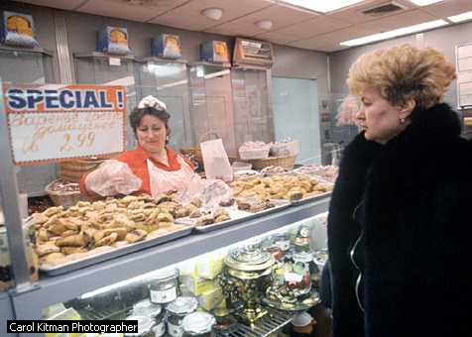
Although McDonald’s remained dedicated to its established format, the company introduced a number of new products and services in the 1970s and 1980s. Many of these innovations proved startlingly successful. McDonald’s began serving breakfast in 1973. By the late 1980s, one-fourth of Americans who ate breakfast away from home did so at McDonald’s. In 1975 McDonald’s introduced drive-through window service, enabling motorists to make purchases without leaving their cars. By the mid-1990s, drive-through business accounted for about half of all McDonald’s sales in the United States. In 1983 the company introduced Chicken McNuggets, bite-sized fried chicken morsels accompanied by dipping sauces. Within a few months McDonald’s ranked as the world’s second largest retailer of chicken.
International expansion also became an important part of the company’s business strategy. McDonald’s opened its first restaurant outside the United States in 1967. In 1988 McDonald’s operated 2600 stores outside the United States, generating $1.8 billion in annual revenues. By 1994 the company had 4700 international franchises, producing $3.4 billion in annual revenues. The first McDonald’s in Moscow, Russia, served more than 30,000 customers on its first day of operation in 1990, setting the record for the most people served by one restaurant in a single day. In 1992 McDonald’s opened a restaurant in Beijing, China. The Beijing McDonald’s—-which featured 700 seats, 2 kitchens, 29 cash registers, and 850 employees—is the company’s largest. The Beijing McDonald’s attracted 40,000 customers on its first day, breaking the record established by the Moscow McDonald’s two years earlier.
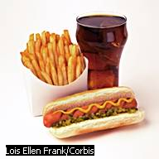
McDonald’s has attempted to accommodate increasing customer demand for healthier food. In 1986 McDonald’s began offering nutritional information about the items on its menu. The company also began to offer lighter entrées, such as salads and frozen yogurt. McDonald’s Arch Deluxe, a hamburger marketed to adults, generated disappointing sales when it was introduced in 1996.
In the mid-1990s the company earned about $1.4 billion a year in profits on $30 billion in sales and opened a new restaurant every three hours. The company has continued to grow in the United States by opening new restaurants in urban areas and establishing smaller outlets in hospitals, zoos, airports, and many other locations. In 1993 McDonald’s began opening outlets in Wal-Mart Stores throughout the United States. In 1996 McDonald’s signed a 10-year agreement with The Walt Disney Company.
Under the terms of the agreement, McDonald’s will operate restaurants at Disney theme parks, and Disney will promote its films through McDonald’s. In 1997 McDonald’s announced a campaign to increase sales at its restaurants by cutting prices.
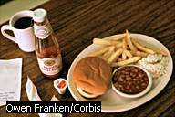

By: Madan Lucian

