Project: dry cell

Author: Costea Irina Mihaela

Course: Chemistry

Class: 10A

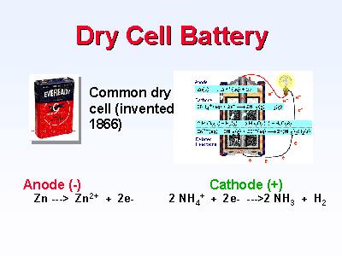

Dry cell
Dry cell (plural dry cells) noun
part of a battery: a current-generating electric cell that cannot be regenerated and contains an electrolyte in the form of a paste or within a porous material to keep it from spilling.
The most common form of primary cell is the Leclanché cell, invented by the French chemist Georges Leclanché in the 1860s. It is popularly called a dry cell or flashlight battery. The Leclanché cell in use today is very similar to the original invention. The electrolyte consists of a mixture of ammonium chloride and zinc chloride made into a paste. The negative electrode is made of zinc, as is the outside shell of the cell, and the positive electrode is a carbon rod surrounded by a mixture of carbon and manganese dioxide. The Leclanché cell produces about 1.5 V.
Dry Cell Battery
The functional elements of a dry cell battery are the negative terminal (a zinc can which encloses the battery materials), the positive terminal (the carbon rod and carbon and manganese dioxide mixture that surrounds the rod), and an electrolyte paste between the two terminals. The electrolytic paste facilitates a chemical reaction involving the constituents of both terminals; this reaction causes a current to flow through a conductor that connects the positive and negative terminals.

In a dry cell the zinc casing serves as the anode and is consumed in the anodic electrode reaction Zn(s) --> Zn²⁺ + 2e⁻; the zinc ion dissolves in the moist ZnCl₂-NH₄Cl electrolyte. A carbon rod serves as the cathode, but it is chemically inert. The cathode electrode reaction, which consumes MnO2, is best written as:
[Mn⁴⁺ + 2O²⁻] + H₂O + e⁻ --> [Mn³⁺ + O²⁻ + OH⁻] + OH⁻
Where the square brackets indicate the species present in the solid phase at the cathode. The cathode reaction actually occurs within the solid structure; the carbon rod serves only to transfer electrons from the external circuit.
The dry cell has a potential difference of about 1.25 V; the zinc electrode is negative. It is a good source of electrical power and the materials of construction are relatively cheap. The cell voltage during discharge falls off rather badly and the dry cell is not a good source of power when a constant voltage is needed.
They are called dry cell because they electrolyte is a paste rather than a liquid.
Types of dry cells:
1. Primary cells - They are not rechargeable. The cell will not function once their chemicals are used up and the cells have to be thrown away. Examples are zinc-carbon cell, alkaline manganese cell and silver oxide cell.
2. Secondary cells - They are rechargeable (can be recharged) and can be used again. Example: nickel-cadmium cell.
Note: The lead-acid accumulator (car battery) used in cars is also a secondary cell but it is not considered as a type of dry cell.

How to make a dry cell
Dry cells are one of the most commonly used household objects. We use dry cells in watches, torches, transistors, walkmans and even the remote controls of our TVs. Dry cells provide the necessary electricity required to power these devices. A normal dry cell is cylindrical in shape made of zinc. A carbon rod passes through its center and a paste of manganese dioxide and ammonium chloride surrounds this rod. When the both ends of the cell are z connected to a bulb through a wire, the bulb glows due to the flow of current. The voltage of such a cell is about 1.5 volt. Let us now make a dry cell at home.
Material Required  - A small carbon plate  - A small zinc plate  - Manganese dioxide  - Starch powder  - Ammonium chloride  - Cotton wool  - Copper wire  - Two metallic clips  - One 1.5 volt bulb and one bulb holder | 